### A Major Project Report On

**“DUAL AXES SMART SOLAR TRACKING SYSTEM”**

**Submitted in partial fulfillment of the requirements for the award of the degree of**

**“BACHELOR OF TECHNOLOGY IN**

**ELECTRICAL AND ELECTRONICS ENGINEERING”**

**(2016-2020)**

**Submitted by:**

**G. RANJITH (16B61A0214)**

**B. GANESH (16B61A0207)**

**B. SAIBENERJI REDDY (16B61A0205) ML. PURUSOTHAM NAICK (16B61A0226)**



**Under the esteemed guidance of Dr. NAGARAJAKUMARI.CH**

**Associate Professor, EEE Department**

**DEPARTMENT OF ELECTRICAL AND ELECTRONICS ENGINEERING**

**NALLA MALLA REDDY ENGINEERING COLLEGE**

**Approved by AICTE, Affiliated to JNTUH, Accredited by NBA, NAAC: A Grade Institution, CodeB6**

**2019-2020**

**NALLA MALLA REDDY ENGINEERING COLLEGE**

**(Approved by AICTE, Accredited by NBA, NAAC: A Grade)**

**7-01, Divyanagar, Kachivanisingaram Post, Ghatkesar, Medchal [Email:info@nmredc.edu.in](mailto:info@nmredc.edu.in) website:** [**www.nmrec.edu.in**](http://www.nmrec.edu.in/)

**CERTIFICATE**

This is to certify that the major project report titled, “**DUAL AXES SMART SOLAR TRACKING SYSTEM**” is being submitted by the following students under our supervision and guidance in partial fulfillment of the requirement for the award of degree of “bachelor of technology” from Jawaharlal Nehru Technological University in Electrical and Electronics Engineering from Nalla Malla Reddy Engineering College for year 2016-2020.

### G .RANJITH (16B61A0214)

**B.GANESH (16B61A0207) B.SAIBENERJI REDDY (16B61A0205) ML.PURUSOTHAM NAICK (16B61A0226)**



**INTERNAL GUIDE**

**Dr. NAGARAJA KUMARI. CH Dr. MOINUDDIN K SYED**

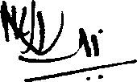

**HoD**

(Associate Professor, EEE) DEPARTMENT OF EEE

## EXTERNAL EXAMINER

**ACKNOWLEDGEMENT**

We take this opportunity to record our gratitude to all those who helped us in successful completion of the project.

We are also highly graceful to our principal **Dr**. **M.N.V. RAMESH** for his cooperation and providing an opportunity to show the talent attained by us in performing this project work.

We wish to express our deep gratitude to **Dr. MOINUDDIN K SYED**, **HOD** of EEE Department, NMREC, Divyanagar, Narapally for his cooperation, encouragement, in addition to providing necessary facilities throughout the project work.

We take immense pleasure in thanking our Head of the Department (Electrical & Electronics Engineering) &Internal guide **Dr. NAGARAJA KUMARI.CH Associate Professor** to carry out this project.

Finally, we wish to express our profound thanks to all the employees, in charges and workmen without their support, completion of project would have been impossible.

**DECLARATION**

**We hereby declare that the project entitled “DUAL AXES SMART SOLAR TRACKING SYSTEM”** that is being submitted by us in the Department of Electrical & Electronics Engineering, **NALLA MALLA REDDY ENGINEERING COLLEGE,** in partial fulfillment for the award of Bachelor of Technology in **ELECTRICAL & ELECTRONICS ENGINEERING.** The work was executed by us under the guidance of our supervisor **Dr. SATYABRATA SAHOO Assoc. Prof.**, Department of EEE and this work is our own and has not been submitted to any other University or any Institute for the award of any Degree/Diploma.

### G. Ranjith (16B61A0214)

**B. Ganesh (16B61A0207)**

**B. Sai Benerji Reddy (16B61A0205) ML. Purusotham Naick (16B61A0226)**

**ABSTRACT**

Photo voltaic effect is one of the methods of converting solar power to electric power. Photo voltaic cells (PV cells), made up of silicon semiconductor material, exhibit the property of photovoltaic effect and converts the solar energy to direct current. The output power of the PV cells depends on the angle of incidence of sunlight. These are able to produce maximum power, as long as the sun light is perpendicular to the panel’s surface. The position of the sun is not stationary so the angle of incidence also changes with time, thereby performance of the solar panel. If the panel is made to align itself perpendicularly to sun rays, maximum efficiency can be achieved. This procedure is called solar tracking. Depending on the number of axes the panel is moving, trackers are differentiated as dual axes and single axis trackers. Dual axes tracker is more efficient than single axis tracker .The tracking mechanism mainly uses LDR sensors to detect the sun’s position, but in the cloudy atmosphere whenever the LDRs cannot locate the sun’s position, automatically activated timer controls the tracking. This project explain about construction of a Dual Axes Solar Tracker using LDR sensors & Timer.This dual axes solar tracker project can also be used to sense temperature and rain moisture,it will be displayed on LCD. This system is powered by Arduino, consisting of servo motor, rain drop sensor, temperature sensor,555 timer and LCD.

iii

|  |  |  |
| --- | --- | --- |
|  | **INDEX** |  |
| Certificates | | I |
| Acknowledgement | | II |
| Declaration | | III |
| Abstract |  | IV |
| List Of Figures | | V |
| List Of Tables | | VI |
| **Chapter-1**  **Dual Axes Smart Solar Tracking System** | | **1-5** |
| 1.1 | Introduction | 1 |
| 1.2 | Literature Review | 2 |
| 1.3 | Proposed System | 5 |
| 1.4 | Aim of Project | 5 |
| **Chapter-2**  **Solar Radiation And Photovoltaic** | | **2-9** |
| 2.1 | Concepts Of Solar Radiation | 6 |
| 2.1.1 | Declination Angles | 6 |
| 2.1.2 | Hour Angles | 7 |
| 2.1.3 | Solar Altitudes | 7 |
| 2.2 | Insolation | 8 |
| 2.3 | Project Work | 8 |
| 2.4 | Working of Photovoltaics | 9 |
| **Chapter-3**  **Solar Tracker** | | **10-11** |
| 3.1 | Introduction | 10 |
| 3.2 | Need Of solar Tracker | 11 |
| 3.3 | Types of solar tracker | 11 |
| 3.3.1 | Single Axis Tracker | 11 |
| 3.3.2 | Dual Axes Tracker | 11 |
| **Chapter-4**  **Embedded System** | | **12-23** |
| 4.1 | Embedded System | 12 |
| 4.1.1 | History | 13 |
| 4.1.2 | Tools | 14 |
| 4.1.3 | Resources | 14 |
| 4.1.4 | Real Time Issues | 15 |
| 4.2 | Need For Embedded System | 15 |
| 4.2.1 | Debugging | 16 |
| 4.2.2 | Reliability | 16 |
| 4.3 | Explanation of Embedded system | 18 |
| 4.3.1 | Software Architecture | 18 |
| 4.3.2 | Stand Alone Application | 19 |
| 4.3.3 | Real Time Embedded System | 20 |

|  |  |  |
| --- | --- | --- |
| 4.3.4 | Network Communication Embedded system | 20 |
| 4.3.5 | Different Types Of Processing Unit | 21 |
| 4.4 | Application of Embedded System | 22 |
| 4.4.1 | Consumer Application | 22 |
| 4.5 | Telecommunication | 22 |
| 4.6 | Computer Networking | 23 |
| **Chapter-5**  **Design Of Solar Tracker** | | **24-60** |
| 5.1 | System Design Block Diagram | 24 |
| 5.2 | Power supply | 24 |
| 5.2.1 | Transformer | 25 |
| 5.2.2 | Rectifier | 26 |
| 5.2.3 | Filter Capaciter | 28 |
| 5.2.4 | Voltage Regulator | 29 |
| 5.2.5 | Circuit Diagram Of Power Supply | 30 |
| 5.3 | Arduino | 31 |
| 5.3.1 | Digital Pins | 33 |
| 5.3.2 | Analog Pins | 33 |
| 5.3.4 | Power Pins | 34 |
| 5.3.5 | Other Pins | 34 |
| 5.3.6 | Pin Diagram | 34 |
| 5.3.7 | AVR CPU Core | 37 |
| 5.3.8 | AVR Architecture | 39 |
| 5.3.9 | Arduino Characteristics | 40 |
| 5.4 | Electromagnetic Relay | 41 |
| 5.5 | Servo motor | 42 |
| 5.6 | Light Dependent Sensor | 43 |
| 5.7 | Solar Panel | 42 |
| 5.8 | Rain sensor | 45 |
| 5.9 | Temperature sensor | 46 |
| 5.9.1 | Lm35 sensor source | 47 |
| 5.9.2 | Lm35 sensor and background application | 48 |
| 5.10.1 | LCD module | 49 |
| 5.10.2 | Commands used in LCD | 51 |
| 5.10.3 | LCD Description | 51 |
| 5.10.4 | Pin Description | 52 |
| 5.10.5 | LCD Background | 53 |
| 5.10.6 | Circuit Description | 55 |
| 5.10.7 | An Example For Hardware Configuration | 56 |
| 5.10.8 | Checking the busy status of LCD | 57 |
| 5.10.9 | Application | 57 |
| 5.11 | 555 Timer | 58 |
| 5.11.1 | Introduction | 58 |
| 5.11.2 | Pin Description | 59 |
|  |  | **61-63** |

|  |  |  |
| --- | --- | --- |
| **Chapter-6**  **Programme** | | |
| 6.1 | Servo motor programme | 62 |
| **Chapter-7**  **Project Work** | | **64-65** |
| 7.1 | Experimental Configuration | 64 |
| 7.2 | Benefits of Solar Tracker | 65 |
| 7.3 | Importance of Timer In Tracking | 65 |
| **VIII Application** | | **66** |
| **IX Advantages** | | **66** |
| **X Conclusion** | | **66** |
| **XII Referencesi** | | **67** |

|  |  |  |
| --- | --- | --- |
|  | **LIST OF FIGURES** |  |
| **S.NO** | **NAME** | **PAGE NO** |
| 1.1 | Sun path | 1 |
| 2.1 | The Declination Angles | 7 |
| 2.2 | Solar altitude and Azimuthal Behaviour Sun path | 7 |
| 2.3 | One Beam One Mile Wide Shine Made 90 On Ground | 8 |
| 2.4 | Photovoltaic cells | 9 |
| 3.1 | Single Axis Tracker | 11 |
| 3.2 | Dual Axes Tracker | 11 |
| 4.1 | A Modern Sample Of Embedded System | 13 |
| 4.2 | Network Communication For Embedded System | 21 |
| 4.3 | Automatic Coffee Make Equipment | 22 |
| 4.4 | Tele Communication Equipment | 22 |
| 4.5 | Computer Networking | 22 |
| 5.1 | Block Diagram | 24 |
| 5.2 | The Regulated Power Supply | 24 |
| 5.3 | The Transformer | 25 |
| 5.4 | Half Wave rectifier | 26 |
| 5.5 | Full Wave rectifier | 26 |
| 5.6 | Bridge Rectifier | 27 |
| 5.7 | Filter Capacitor | 28 |
| 5.8 | Wave Form | 28 |
| 5.9 | Voltage Regulator | 29 |
| 5.10 | Power Supply Circuit Diagram | 30 |
| 5.11 | Structure of Arduino Board | 31 |
| 5.12 | Arduino Board | 32 |
| 5.13 | Pin Configuration of Atmega 328 | 34 |
| 5.14 | AVR Block diagram | 37 |
| 5.15 | AVR Architecture | 38 |
| 5.16 | Electromagnetic Relay | 41 |
| 5.17 | Servo Motor | 42 |
| 5.18 | LDR | 43 |
| 5.19 | Solar Panel | 44 |
| 5.20 | Rain Sensor | 45 |
| 5.21 | Circuit Diagram of LM35 | 46 |
| 5.22 | LM35 Pinouts and Packaging | 47 |
| 5.23 | 2*16 Alphanumeric LCD Display | 50 |
| 5.24 | LED Backlight | 51 |
| 5.25 | LCD Pin Diagram | 52 |
| 5.26 | LCD Circuit Description | 55 |
| 5.27 | LCD Connection | 56 |
| 5.28 | 555 Timer 8-Pin T-package & V-package | 59 |
| 5.29 | 555 Timer Circuit Diagram | 59 |
| 7.1 | Experimental Configuration of Solar Panel | 64 |

|  |  |  |
| --- | --- | --- |
|  | **LIST OF TABLES** |  |
| **S.NO** | **NAME** | **PAGE NO** |
| 5.1 | LCD Module | 50 |
| 5.2 | Basic 16*2 Character LCD black On Green 5v | 51 |
| 5.3 | Character of LCD Pin Controller 1 | 52 |
| 5.4 | Character of LCD Pin Controller 2 | 53 |

# CHAPTER-I

**DUAL AXES SMART SOLAR TRACKING SYSTEM**

## INTRODUCTION

Inventors unlocked the secrets of turning the sun’s rays into mechanical power more than a century ago. In olden days, mostly people used solar panels to produce thermal energy (concentrating method). After the invention of photo voltaic cells by using silicon, germanium type materials, solar history turned to a new generation. Solar also become an effective renewable energy source. The output of the solar panels mostly depends on the intensity of sun rays and the angle of incidence. As the sun is always moving the angle of incidence always changes. The output will be maximized whenever sun rays fall perpendicular to the panel. In initial days scientist used to arrange the solar panels in stationary position at a particular angle, such that the panel faces the sun most of the time. After the advanced experiments on the sun's path, scientists introduced one manual method, changing the solar panel tilting angle for every 3 months to improve output. Nowadays one best practice has come into the solar world that is solar tracking. A solar tracking is a method of orienting a PV panel toward the sun automatically. Solar tracking decreases the angle of incidence of sun’s rays on the panel. This maximizes the output power from a fixed amount of installed power generator. Tracking can be classified into two types: Dual axes and Single Axis. In Single axis solar tracker, solar panel moves in one direction (using single motor) where as in dual axes solar tracking panel moves in two directions (using two motors). The single axes tracker is very useful when the sun’s path is stationary but as the sun’s path changes with season as shown in figure, The Dual axes tracker, which follows the sun irrespective of its path, is very efficient.

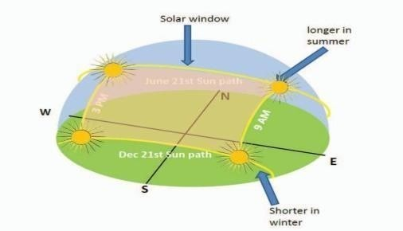

### Figure 1.1 Sun Path

Solar energy is coming up as a major source of energy. The need of the hour is renewable energy resources with cheap running costs. With the current systems for solar energy harvesting, we have high production only at fixed times mostly noon. This project proposes a dual axis solar tracker system that increases the productivity by a significant margin.

**SOLAR ANGLE;** The angle of inclination ranges between -90° after sun rise and +90° before sunset passing with 0° at noon. This makes the collected solar radiation to be 0% at sunrise and sunset and 100% at noon. This variation of solar radiations collection leads the photovoltaic panel to lose more than 40% of the collected energy. In this project, we take you through designing a solar tracker so that you maximise on the solar energy collection.

**DESIGNING OF DUAL AXES TRACKING SYSTEM: :**This system requires involvement of a wide range of engineering including mechanical electrical and electronics. The system can be broken down into these three domains as well. The mechanical part would involve designing a smooth gear system to move as per requirement. The electrical part would be the working of solar panel and battery requirement. The electronics would involve designing the sensor system that would generate commands for the gear system to act accordingly.

## LITERATURE REVIEW

The generation of power from the reduction of fossil fuels is the biggest challenge for the next half century. The idea of converting solar energy into electrical energy using photovoltaic panels holds its place in the front row compared to other renewable sources. But the continuous change in the relative angle of the sun with reference to the earth reduces the watts delivered by solar panel. In this context solar tracking system is the best alternative to increase the efficiency of the photovoltaic panel.

Solar trackers move the payload towards the sun throughout the day. Dual axis tracking system is more efficient compared to other tracking systems. A two- axis solar tracker capable of withstanding the extreme weather conditions. The solar tracker includes a solar array, a frame, a base, a pivot frame, and a first and second actuator. The solar array is mounted to the frame and captures sunlight. The base is pivotally connected to the frame and defines a pivot axis for

elevational movement of the solar array. The pivot frame is also pivotally connected to the frame and defines a pivot axis for azimuthal movement of the solar array. The base is pivotally connected to the frame and defines a pivot axis for elevational movement of the solar array. The pivot frame is also pivotally connected to the frame and defines a pivot axis for azimuthal movement of the solar array. The first actuator controls elevational movement of the solar array and the second actuator controls azimuthal movement of the solar array. The solar tracker is pivotable between a raised position and a stowed position.[**1**]

Sun-synchronous navigation is related to moving the solar powered rover (robot) in such a way that its solar panel always points toward the sun and which results into maximum battery charging and hence the rover can work for long hours. The unique feature of this solar tracking system is that instead of taking the earth as its reference, it takes the sun as a guiding source. Its active sensors constantly monitor the sunlight and rotate the panel towards the direction where the intensity of sunlight is maximum.

The light dependent resistor’s do the job of sensing the change in the position of the Sun. The control circuit does the job of fetching the input from the sensor and gives command to the motor to run in order to tackle the change in the position of the sun. By using this system, the additional energy generated is around 25% to 30% with very less consumption by the system itself.

The paper gives the design and implementation of a fuzzy logic computer-controlled sun tracking system to enhance the power output of photo voltaic solar panels. The tracking system was driven by two permanent magnet DC motors to provide motion of the PV panels in two axes.

The project describes the use of a microcontroller-based design methodology of an automatic solar tracker. Light dependent resistors are used as the sensors of the solar tracker. The tracking system maximizes solar cell output by positioning a solar panel at the point of maximum light intensity. This paper describes the use of DC motors, special motors like stepper motors, servo motors, real time actuators, to operate moving parts of the solar tracker.

The system was designed as the normal line of solar cell always move parallel to the rays of the sun. The Aim of this project is to develop and implement a prototype of two-axis solar tracking system based on a microcontroller.

The parabolic reflector or parabolic dish is constructed around two feed diameter to capture the sun’s energy. The focus of the parabolic reflector is pointed to a small area to get extremely high temperature. The temperature at the focus of the parabolic reflector is measured with temperature probes. This auto-tracking system is controlled with two 12V, 6W DC gear box motors. The five light sensors (LDR) are used to track the sun and to start the operation (Day/Night operation). The project concentrates on the design and control of dual axis orientation system for the photovoltaic solar panels.

The orientation system calculations are based on astronomical data and the system is assumed to be valid for any region with small modifications. The system is designed to control the Altitude angle in the vertical plane as well as the Azimuth angle in the horizontal plane of the photovoltaic panel workspace. And this system is expected to save more than 40% of the total energy of the panels by keeping the panel’s face perpendicular to the sun.

In the previous solutions, each tracking direction is controlled by using a Sun sensor made by a pair of phototransistors. The single matrix Sun sensor (MSS) controls both axes of the tracking system. The inspiration for the MSS is the antique solar clock.

MSS comprises 8 photo resistors and a cylinder The difference between a shaded photo resistor cell and a lighted cell is recognized using an electronic circuit and corresponding output voltage signals are given to the DC motors which will move the array toward sun. In order to improve the solar tracking accuracy, the author comes up with combining program control and sensor control. Program control includes calendar-check tracking and the local longitude, latitude and time, to calculate the solar altitude and solar azimuth by SCM (single-chip microcomputer), servo motor is used to adjust the attitude of the solar panel. Sensor control is that sunray is detected by photoelectric detector and then the changed signal is transmitted to control step motor to adjust the attitude of the solar.

The paper discusses the technology options, their current status and opportunities and challenges in developing solar thermal power plants in the context of India. The National Solar Mission is a major initiative of the Government of India and State Governments to promote ecologically sustainable growth while addressing India’s energy security challenge. It will also constitute a major contribution by India to the global effort to meet the challenges of climate change.[**2**]

## PROPOSED SYSTEM

This project consists of few LDR sensors and a motorized mechanism for rotating the panel in the direction of sun. Moving the solar cell panel in the direction of sun can increase the solar energy generated from the solar cell. Microcontroller based control system takes care of sensing sunlight and controlling the motorized mechanism. This system works continuously without any interruption. Here rain sensor is used to identify the presence of rain, and temperature sensor is used to know the temperature in the atmosphere. And the information will also show in LCD.

## AIM OF THE PROJECT

The aim of the project is to keep the solar photovoltaic panel perpendicular to the sun throughout the year in order to make it more efficient. The dual axis solar photovoltaic panel takes astronomical data as reference and the tracking system has the capability to always point the solar array toward the sun and can be installed in various regions with minor modifications. The vertical and horizontal motion of the panel is obtained by taking altitude angle and azimuth angle as reference. The fuzzy controller has been used to control the position of DC motors. The mathematical simulation control of dual axis solar tracking system ensures the point to point motion of the DC motors while tracking the sun.

# CHAPTER-II

**SOLAR RADIATION & PHOTOVOLTAIC**

### CONCEPTS ON SOLAR RADIATION

Before talking about the solar tracking systems, we will review some basic concepts concerning solar radiation and mention some important values to better understand the results of this work. The sun, at an estimated temperature of 5800 K, emits high amounts of energy in the form of radiation, which reaches the planets of the solar system. Sunlight has two components, the direct beam and diffuse beam. Direct radiation (also called beam radiation) is the solar radiation of the sun that has not been scattered (causes shadow).

Direct beam carries about 90% of the solar energy, and the "diffuse sunlight" that carries the remainder. The diffuse portion is the blue sky on a clear day and increases as a proportion on cloudy days. The diffuse radiation is the sun radiation that has been scattered (complete radiation on cloudy days). Reflected radiation is the incident radiation (beam and diffuse) that has been reflected by the earth.

The sum of beams, diffuse and reflected radiation is considered as the global radiation on a surface. As the majority of the energy is in the direct beam, maximizing collection requires the sun to be visible to the panels as long as possible.

### DECLINATION ANGLE:

The declination of the sun is the angle between the equator and a line drawn from the centre of the Earth to the centre of the sun. The declination is maximum (23.450) on the summer/winter (in India 21 June and 22 December) The declination angle, denoted by δ, varies seasonally due to the tilt of the Earth on its axis of rotation and the rotation of the Earth around the sun.

If the Earth were not tilted on its axis of rotation, the declination would always be 0°. However, the Earth is tilted by 23.45° and the declination angle varies plus or minus this amount. Only at the spring and fall equinoxes is the declination angle equal to 0°.

### HOUR ANGLE:

The Hour Angle is the angular distance that the earth has rotated in a day. It is equal to 15 degrees multiplied by the number of hours from local solar noon. This is based on the nominal time, 24

hours, required for the earth to rotate once i.e. 360 degrees. Solar hour angle is zero when sun is straight over head, negative before noon, and positive after noon. (here noon means 12.00 hour)

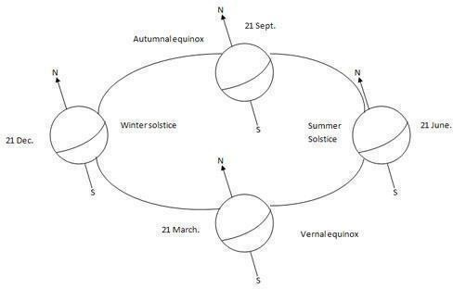

### Figure 2.1 The Declination Angles

* + 1. **SOLAR ALTITUDE (Θz):**

The solar altitude is the vertical angle between the horizontal and the line connecting to the sun. At sunset/sunrise altitude is 0 and is 90 degrees when the sun is at the zenith. The altitude relates to the latitude of the site, the declination angle and the hour angle.2.1.4 Solar Azimuth (θ*A*):

The azimuth angle is the angle within the horizontal plane measured from true South or North. The azimuth angle is measured clockwise from the zero azimuth. For example, if you're in the Northern Hemisphere and the zero azimuth is set to South, the azimuth angle value will be negative before solar noon, and positive after solar noon.

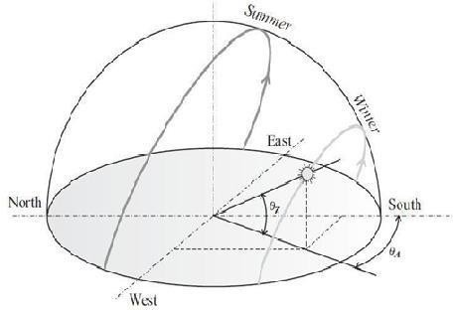

### Figure 2.2 Solar Altitude and Azimuthal Behavior Sun Path

* 1. **INSOLATION**

Insolation is a measure of solar radiation energy received on a given surface area and recorded during a given time. It is also called solar irradiation and expressed as hourly irradiation if recorded during an hour, daily irradiation if recorded during a day, for example. The unit recommended by the World Meteorological Organization is MJ/m2 (mega joules per square meter) or J/cm2 (joules

per square centimeter). Practitioners in the business of solar energy may use the unit Wh/m2 (watt- hours per square meter).

If this energy is divided by the recording time in hours, it is then a density of power called irradiance, expressed in W/m2 (watts per square meter). Over the course of a year the average solar radiation arriving at the top of the Earth's atmosphere at any point in time is roughly 1366 watts per square meter. The Sun's rays are attenuated as they pass through the atmosphere, thus reducing the irradiance at the Earth's surface to approximately 1000 W m−2 for a surface perpendicular to the Sun's rays at sea level on a clear day. The insolation of the sun can also be expressed in Suns, where one Sun equals 1000 W/m2

### PROJECTION EFFECT

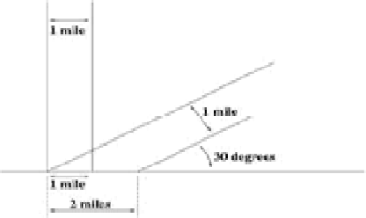The insolation into a surface is largest when the surface directly faces the Sun. As the angle increases between the direction at a right angle to the surface and the direction of the rays of sunlight, the insolation is reduced in proportion to cosine of the angle; see effect of sun angle on climate. This 'projection effect' is the main reason why the Polar Regions are much colder than equatorial regions on Earth. On an annual average the poles receive less insolation than does the equator, because at the poles the Earth's surface are angled away from the Sun

### Figure 2.3 One Beam One Mile Wide Shine Made 90 On Ground

* 1. **WORKING OF PHOTOVOLTAICS**

Photovoltaics are the direct conversion of light into electricity at the atomic level. Some materials exhibit a property known as the photoelectric effect that causes them to absorb photons of light and release electrons. When these free electrons are captured, an electric current result that can be used as electricity. A solar cell (also called photovoltaic cell or photoelectric cell) is a solid-state electrical device that converts the energy of light directly into electricity by the photovoltaic effect. Crystalline silicon PV cells are the most common photovoltaic cells in use today.

A number of solar cells electrically connected to each other and mounted in a support structure or frame are called a photovoltaic module. Modules are designed to supply electricity at a certain voltage, such as a common 12 volts system. The current produced is directly dependent on how much light strikes the module. Multiple modules can be wired together to form an array. In general, the larger the area of a module or array, the more electricity will be produced. Photovoltaic modules and arrays produce direct-current (DC) electricity. They can be connected in both series and parallel electrical arrangements to produce any required voltage and current combination.

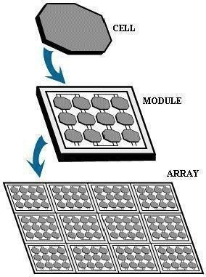

### Figure 2.4 Photovoltaic Cells

**CHAPTER-III SOLAR TRACKER**

* 1. **INTRODUCTION**

Solar Tracker is a Device which follows the movement of the sun as it rotates from the east to the west every day. The main function of all tracking systems is to provide one or two degrees of freedom in movement. Trackers are used to keep solar collectors/solar panels oriented directly towards the sun as it moves through the sky every day. Using solar trackers increases the amount of solar energy which is received by the solar energy collector and improves the energy output of the heat/electricity which is generated. Solar trackers can increase the output of solar panels by 20- 30% which improves the economics of the solar panel project.

### NEED FOR SOLAR TRACKER

The energy contributed by the direct beam drops off with the cosine of the angle between the incoming light and the panel. The table no. 2.1 shows the Direct power lost (%) due to misalignment (angle *i*).

The sun travels through 360 degrees east-west a day, but from the perspective of any fixed location the visible portion is 180 degrees during a 1/2-day period. Local horizon effects reduce this somewhat, making the effective motion about 150 degrees. A solar panel in a fixed orientation between the dawn and sunset extremes will see a motion of 75 degrees on either side, and thus, according to the table above, will lose 75% of the energy in the morning and evening. Rotating the panels to the east and west can help recapture these losses. A tracker rotating in the east-west direction is known as a single-axis tracker.

The sun also moves through 46 degrees north-south over the period of a year. The same set of panels set at the midpoint between the two local extremes will thus see the sun move 23 degrees on either side, causing losses of 8.3% A tracker that accounts for both the daily and seasonal motions is known as a dual-axis tracker.

### TYPES OF SOLAR TRACKERS

* + 1. **Single Axis Tracker**

The single axis tracking systems realizes the movement of either elevation or azimuth for a solar power system. Which one of these movements is desired, depends on the technology used on the tracker as well as the space that it is mounted on, example the parabolic through systems utilize the azimuthally tracking whereas the many rooftop PV-systems utilize elevation tracking because of the lack of space. A single-axis tracker can only pivot in one plane – either horizontally or vertically.

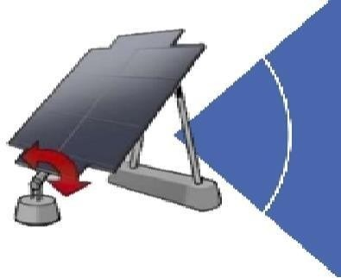

### Figure 3.1 Single Axis Solar Tracker

* + 1. **Dual Axes Tracker**

Dual axis trackers as shown in the figure 2.6 have two degrees of freedom that act as axes of rotation. Double-axis solar trackers, as the same suggest, can rotate simultaneously in horizontal and vertical directions, and s o are able to point exactly at the sun at all times in any location. Dual axis tracking systems realize movement both along the elevation- and azimuthally axes. These tracking systems naturally provide the best performance, given that the components have high enough accuracy as well.

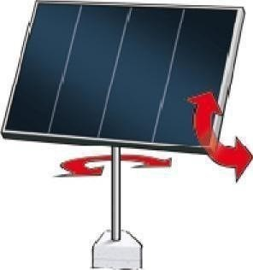

### Figure 3.2 Dual Axes Solar Tracker

**CHAPTER-IV EMBEDDED SYSTEM**

* 1. **EMBEDDED SYSTEM**

An embedded system is a computer system designed to perform one or a few dedicated functions often with real-time computing constraints. It is embedded as part of a complete device often including hardware and mechanical parts. By contrast, a general-purpose computer, such as a personal computer (PC), is designed to be flexible and to meet a wide range of end-user needs. Embedded systems control many devices in common use today.

Embedded systems are controlled by one or more main processing cores that are typically either microcontrollers or digital signal processors (DSP). The key characteristic, however, is being dedicated to handle a particular task, which may require very powerful processors. For example, air traffic control systems may usefully be viewed as embedded, even though they involve mainframe computers and dedicated regional and national networks between airports and radar sites. (Each radar probably includes one or more embedded systems of its own.)

Since the embedded system is dedicated to specific tasks, design engineers can optimize it to reduce the size and cost of the product and increase the reliability and performance. Some embedded systems are mass-produced, benefiting from economies of scale.

Physically embedded systems range from portable devices such as digital watches and MP3 players, to large stationary installations like traffic lights, factory controllers, or the systems controlling nuclear power plants. Complexity varies from low, with a single microcontroller chip, to very high with multiple units, peripherals and networks mounted inside a large chassis or enclosure.

In general, "embedded system" is not a strictly definable term, as most systems have some element of extensibility or programmability. For example, handheld computers share some elements with embedded systems such as the operating systems and microprocessors which power them, but they allow different applications to be loaded and peripherals to be connected. Moreover, even systems which don't expose programmability as a primary feature generally need to support software updates. On a continuum from "general purpose" to "embedded", large application systems will have subcomponents at most points even if the system as a whole is "designed to perform one or a few dedicated functions", and is thus appropriate to call "embedded". A modern example of embedded system is shown in fig: 2.1.

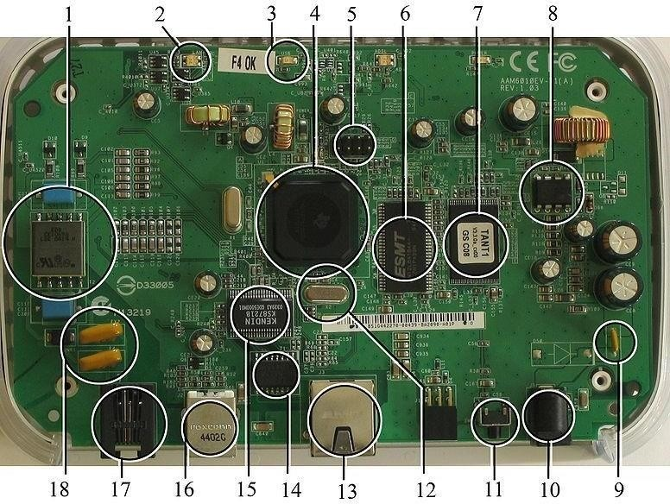

### Figure 4.1 A Modern Example of Embedded System

Labeled parts include microprocessor (4), RAM (6), flash memory (7). Embedded systems programming is not like normal PC programming. In many ways, programming for an embedded system is like programming PC 15 years ago. The hardware for the system is usually chosen to make the device as cheap as possible. Spending an extra dollar a unit in order to make things easier to program can cost millions. Hiring a programmer for an extra month is cheap in comparison

### HISTORY

In the earliest years of computers in the 1930–40s, computers were sometimes dedicated to a single task, but were far too large and expensive for most kinds of tasks performed by embedded computers of today. Over time however, the concept of controllers evolved from traditional electromechanical sequencers, via solid state devices, to the use of computer technology.

One of the first recognizably modern embedded systems was the Apollo Guidance Computer, developed by [Charles Stark Draper](http://en.wikipedia.org/wiki/Charles_Stark_Draper) at the MIT Instrumentation Laboratory. At the project's inception, the Apollo guidance computer was considered the riskiest item in the Apollo project as it employed the then newly developed monolithic integrated circuits to reduce the size and weight. An early mass-produced embedded system was the Autonetics D-17 guidance computer for the [Minuteman missile](http://en.wikipedia.org/wiki/Minuteman_(missile)), released in 1961. It was built from [transistor](http://en.wikipedia.org/wiki/Transistor) [logic](http://en.wikipedia.org/wiki/Digital_circuit) and had a disk for main

memory. When the Minuteman II went into production in 1966, the D-17 was replaced with a new computer that was the first high-volume use of integrated circuits.

### TOOLS

Embedded development makes up a small fraction of total programming. There's also a large number of embedded architectures, unlike the PC world where 1 instruction set rules, and the UNIX world where there's only 3 or 4 major ones. This means that the tools are more expensive. It also means that they're lowering featured, and less developed. On a major embedded project, at some point you will almost always find a compiler bug of some sort.

Debugging tools are another issue. Since you can't always run general programs on your embedded processor, you can't always run a debugger on it. This makes fixing your program difficult. Special hardware such as JTAG ports can overcome this issue in part. However, if you stop on a breakpoint when your system is controlling real world hardware (such as a motor), permanent equipment damage can occur. As a result, people doing embedded programming quickly become masters at using serial IO channels and error message style debugging.

### RESOURCES

To save costs, embedded systems frequently have the cheapest processors that can do the job. This means your programs need to be written as efficiently as possible. When dealing with large data sets, issues like memory cache misses that never matter in PC programming can hurt you. Luckily, this won't happen too often- use reasonably efficient algorithms to start, and optimize only when necessary. Of course, normal profilers won't work well, due to the same reason debuggers don't work well.

Memory is also an issue. For the same cost savings reasons, embedded systems usually have the least memory they can get away with. That means their algorithms must be memory efficient (unlike in PC programs, you will frequently sacrifice processor time for memory, rather than the reverse). It also means you can't afford to leak memory. Embedded applications generally use deterministic memory techniques and avoid the default "new" and "malloc" functions, so that leaks can be found and eliminated more easily. Other resources programmers expect may not even exist. For example, most embedded processors do not have hardware FPUs (Floating-Point Processing Unit). These resources either need to be emulated in software, or avoided altogether.

### REAL TIME ISSUES

Embedded systems frequently control hardware, and must be able to respond to them in real time. Failure to do so could cause inaccuracy in measurements, or even damage hardware such as motors. This is made even more difficult by the lack of resources available. Almost all embedded systems need to be able to prioritize some tasks over others, and to be able to put off/skip low priority tasks such as UI in favor of high priority tasks like hardware control.

### NEED FOR EMBEDDED SYSTEM

The uses of embedded systems are virtually limitless, because every day new products are introduced to the market that utilizes embedded computers in novel ways. In recent years, hardware such as microprocessors, microcontrollers, and FPGA chips have become much cheaper. So, when implementing a new form of control, it's wiser to just buy the generic chip and write your own custom software for it. Producing a custom-made chip to handle a particular task or set of tasks costs far more time and money. Many embedded computers even come with extensive libraries, so that "writing your own software" becomes a very trivial task indeed. From an implementation viewpoint, there is a major difference between a computer and an embedded system. Embedded systems are often required to provide Real-Time response. The main elements that make embedded systems unique are its reliability and ease in debugging.

### DEBUGGING

Embedded debugging may be performed at different levels, depending on the facilities available. From simplest to most sophisticate they can be roughly grouped into the following areas: Interactive resident debugging, using the simple shell provided by the embedded operating system (e.g. Forth and Basic)External debugging using logging or serial port output to trace operation using either a monitor in flash or using a debug server like the Remedy Debugger which even works for heterogeneous multi core systems. An in-circuit debugger (ICD), a hardware device that connects to the microprocessor via a JTAG or Nexus interface.

This allows the operation of the microprocessor to be controlled externally, but is typically restricted to specific debugging capabilities in the processor. An in-circuit emulator replaces the microprocessor with a simulated equivalent, providing full control over all aspects of the

microprocessor.

A complete emulator provides a simulation of all aspects of the hardware, allowing all of it to be controlled and modified and allowing debugging on a normal PC. Unless restricted to external debugging, the programmer can typically load and run software through the tools, view the code running in the processor, and start or stop its operation.

The view of the code may be as assembly code or source-code. Because an embedded system is often composed of a wide variety of elements, the debugging strategy may vary. For instance, debugging a software (and microprocessor) centric embedded system is different from debugging an embedded system where most of the processing is performed by peripherals (DSP, FPGA, co- processor).

An increasing number of embedded systems today use more than one single processor core. wish to check the data traffic on the busses between the processor cores, which requires very low-level debugging, at signal/bus level, with a logic analyzer, for instance. In such a case, the embedded system design may

### RELIABILITY

Embedded systems often reside in machines that are expected to run continuously for years without errors and in some cases recover by them if an error occurs. Therefore, the software is usually developed and tested more carefully than that for personal computers, and unreliable mechanical moving parts such as disk drives, switches or buttons are avoided.

#### Specific reliability issues may include:

* The system cannot safely be shut down for repair, or it is too inaccessible to repair. Examples include space systems, undersea cables, navigational beacons, bore-hole systems, and automobiles.
* The system must be kept running for safety reasons. "Limp modes" are less tolerable. Often backups are selected by an operator. Examples include aircraft navigation, reactor control systems, safety-critical chemical factory controls, train signals, engines on single-engine aircraft.
* The system will lose large amounts of money when shut down: Telephone switches, factory controls, bridge and elevator controls, funds transfer and market making, automated sales and service.

A variety of techniques are used, sometimes in combination, to recover from errors—both software bugs such as memory leaks, and also soft errors in the hardware:

* Watchdog timer that resets the computer unless the software periodically notifies the watchdog
* Subsystems with redundant spares that can be switched over to
* software "limp modes" that provide partial function
* Designing with a Trusted Computing Base (TCB) architecture [6] ensures a highly secure & reliable system environment
* An Embedded Hypervisor is able to provide secure encapsulation for any subsystem component, so that a compromised software component cannot interfere with other subsystems, or privileged-level system software.
* This encapsulation keeps faults from propagating from one subsystem to another, improving reliability. This may also allow a subsystem to be automatically shut down and restarted on fault detection.
* Immunity Aware Programming

### EXPLANATION OF EMBEDDED SYSTEM

* + 1. **SOFTWARE ARCHITECTURE**

There are several different types of software architecture in common use.

### Simple Control Loop

In this design, the software simply has a loop. The loop calls subroutines, each of which manages a part of the hardware or software.

### Interrupt Controlled System

Some embedded systems are predominantly interrupt controlled. This means that tasks performed by the system are triggered by different kinds of events. An interrupt could be generated for example by a timer in a predefined frequency, or by a serial port controller receiving a byte. These kinds of systems are used if event handlers need low latency and the event handlers are short and simple. Usually these kinds of systems run a simple task in a main loop also, but this task is not very sensitive to unexpected delays. Sometimes the interrupt handler will add longer tasks to a queue structure. Later, after the interrupt handler has finished, these tasks are executed by the main

loop. This method brings the system close to a multitasking kernel with discrete processes.

### Cooperative Multitasking

A non-preemptive multitasking system is very similar to the simple control loop scheme, except that the loop is hidden in an API. The programmer defines a series of tasks, and each task gets its own environment to “run” in. When a task is idle, it calls an idle routine, usually called “pause”, “wait”, “yield”, “nop” (stands for no operation), etc. The advantages and disadvantages are very similar to the control loop, except that adding new software is easier, by simply writing a new task, or adding to the queue-interpreter.

### Primitive Multitasking:

In this type of system, a low-level piece of code switches between tasks or threads based on a timer (connected to an interrupt). This is the level at which the system is generally considered to have an "operating system" kernel. Depending on how much functionality is required, it introduces more or less of the complexities of managing multiple tasks running conceptually in parallel.

As any code can potentially damage the data of another task (except in larger systems using an MMU) programs must be carefully designed and tested, and access to shared data must be controlled by some synchronization strategy, such as message queues, semaphores or a non- blocking synchronization scheme.

Because of these complexities, it is common for organizations to buy a real-time operating system, allowing the application programmers to concentrate on device functionality rather than operating system services, at least for large systems; smaller systems often cannot afford the overhead associated with a generic real time system, due to limitations regarding memory size, performance, and/or battery life.

### Microkernels and Exokernels

A microkernel is a logical step up from a real-time OS. The usual arrangement is that the operating system kernel allocates memory and switches the CPU to different threads of execution. User mode processes implement major functions such as file systems, network interfaces, etc.

In general, microkernels succeed when the task switching and intertask communication is fast, and fail when they are slow. Exokernels communicate efficiently by normal subroutine calls. The hardware and all the software in the system are available to, and extensible by application programmers. Based on performance, functionality, requirement the embedded systems are divided into three categories:

### STAND ALONE APPLICATION

These systems take the input in the form of electrical signals from transducers or commands from human beings such as pressing of a button etc.., process them and produces desired output. This entire process of taking input, processing it and giving output is done in standalone mode. Such embedded systems come under standalone embedded systems e.g., microwave oven, air conditioner etc. there is a process of taking input, processing it and giving output is done in standalone mode. Such embedded systems come under standalone embedded systems e.g., microwave oven, air conditioner etc.

### REAL TIME EMBEDDED SYSTEM

Embedded systems which are used to perform a specific task or operation in a specific time period those systems are called as real-time embedded systems. There are two types of real-time embedded systems.

### Hard Real-time embedded systems:

These embedded systems follow an absolute dead line time period i.e.., if the tasking is not done in a particular time period then there is a cause of damage to the entire equipment.

e.g., consider a system in which we have to open a valve within 30 milliseconds. If this valve is not opened in 30 ms this may cause damage to the entire equipment. So in such cases we use embedded systems for doing automatic operations.

### Soft Real Time embedded systems:

e.g., Consider a TV remote control system, if the remote control takes a few milliseconds delay it will not cause damage either to the TV or to the remote control. These systems which will not

### NETWORK COMMUNICATION EMBEDDED SYSTEM

A wide range network interfacing communication is provided by using embedded systems. Example, consider a web camera that is connected to the computer with internet can be used to spread communication like sending pictures, images, videos etc.., to another computer with internet connection throughout anywhere in the world.

Consider a web camera that is connected at the door lock. The desktop of your computer, and then you can open the door lock just by clicking the mouse. Fig: 2.2 show the network communications

in embedded systems.

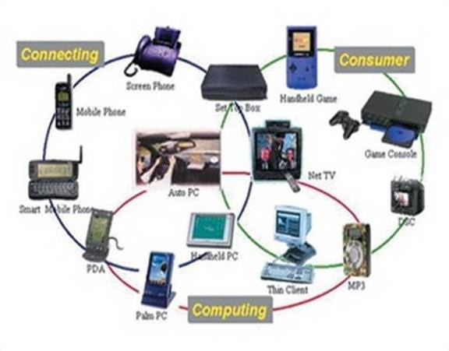

### Figure 4.2 Network Communication for Embedded System

* + 1. **DIFFERENT TYPES OF PROCESSING UNIT**

The central processing unit (C.P.U.) can be any one of the following microprocessors, microcontroller, digital signal processing.

Among these Microcontroller is of low-cost processor and one of the main advantage of microcontrollers is, the components such as memory, serial communication interfaces, analog to Microprocessors are more powerful than microcontrollers. They are used in major applications with a number of tasking requirements. But the microprocessor requires many external components like memory, serial communication, hard disk, input output ports etc.., so digital signal processing is used mainly for the applications that particularly involved with processing of signals.

### APPLICATIONS OF EMBEDDED SYSTEMS:

* + 1. **CONSUMER APPLICATION:**

At home we use a number of embedded systems which include microwave oven, remote control, VCD players, DVD players, camera etc….

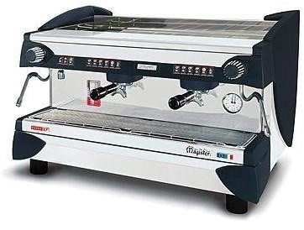

### Figure 4.3 Automatic Coffee Make Equipment

**4.5. TELECOMMUNICATION:**

Today a lot of industries are using embedded systems for process control. In industries we design the embedded systems to perform a specific operation like monitoring temperature, pressure, humidity, voltage, current etc.., and basing on these monitored levels we do control other devices, we can send information to a centralized monitoring station.

In critical industries where human presence is avoided there, we can use vehicles which are programmed to do a specific operation.

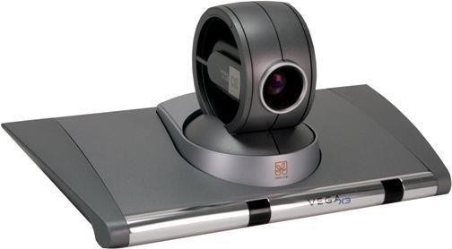

### Figure 4.4 Tele Communication

**4.6 COMPUTER NETWORKING**

Embedded systems are used as bridges routers etc.

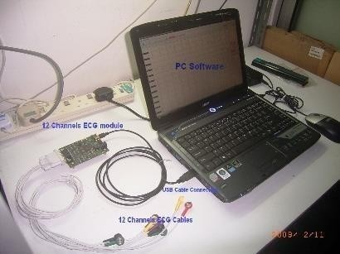

### Figure 4.5 Computer Networking

**CHAPTER-V**

**DESIGN OF SOLAR TRACKER**

* 1. **SYSTEM DESIGN BLOCK DIAGRAM**

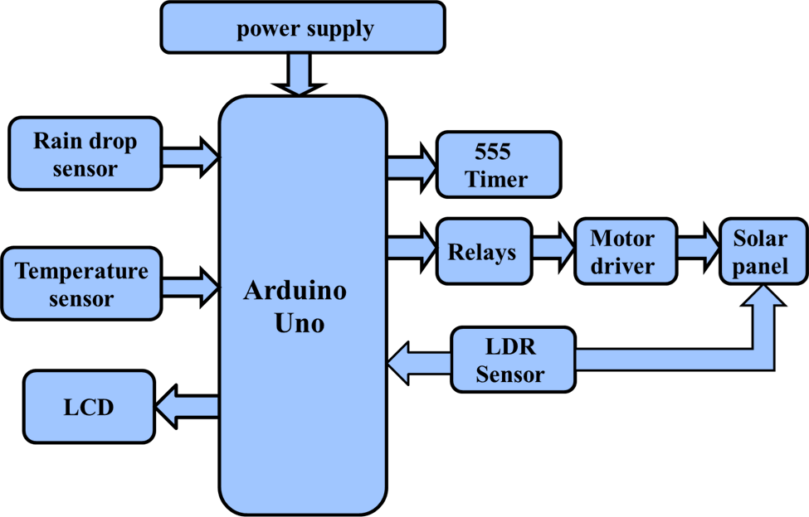

**Figure 5.1 Block Diagram**

* 1. **POWER SUPPLY**

All digital circuits require regulated power supply. In this article we are going to learn how to get a regulated positive supply from the mains supply.



### Figure 5.2 The Regulated Power Supply

* + 1. **TRANSFORMER**

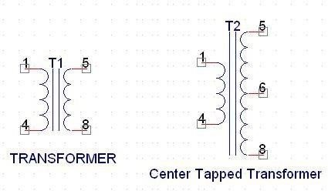

**Figure 5.3 The Transformer**

A transformer consists of two coils also called as “WINDINGS” namely PRIMARY &

SECONDARY.

They are linked together through inductively coupled electrical conductors also called as CORE. A changing current in the primary causes a change in the Magnetic Field in the core & this in turn induces an alternating voltage in the secondary coil. If load is applied to the secondary then an alternating current will flow through the load. If we consider an ideal condition then all the energy from the primary circuit will be transferred to the secondary circuit through the magnetic field.



So





The secondary voltage of the transformer depends on the number of turns in the Primary as well as in the secondary.

### RECTIFIER

A rectifier is a device that converts an AC signal into DC signal. For rectification purpose we use a diode, a diode is a device that allows current to pass only in one direction i.e. when the anodeof the diode is positive with respect to the cathode also called as forward biased condition & blocks current in the reversed biased condition.

#### Rectifier can be classified as follows:

1. **HALF WAVE RECTIFIER**

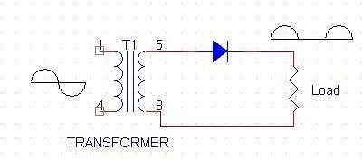

**Figure 5.4 Half Wave Rectifier**

This is the simplest type of rectifier as you can see in the diagram a half wave rectifier consists of only one diode. When an AC signal is applied to it during the positive half cycle the diode is forward biased & current flows through it. But during the negative half cycle diode is reverse biased & no current flows through it. Since only one half of the input reaches the output, it is very efficient to use power supply

### FULL WAVE RECTIFIER

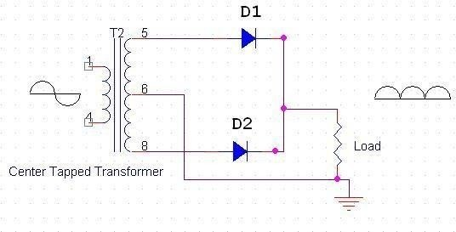

**Figure 5.5 Full Wave Rectifier**

Half wave rectifier is quite simple but it is very inefficient, for greater efficiency we would like to use both the half cycles of the AC signal. This can be achieved by using a center tapped transformer

i.e. we would have to double the size of secondary winding & provide connection to the center. So, during the positive half cycle diode D1 conducts & D2 is in reverse biased condition. During the negative half cycle diode D2 conducts & D1 is reverse biased. Thus, we get both the half cycles across the load.

One of the disadvantages of Full Wave Rectifier design is the necessity of using a center tapped transformer, thus increasing the size & cost of the circuit. This can be avoided by using the Full Wave Bridge Rectifier.

### BRIDGE RECTIFIER

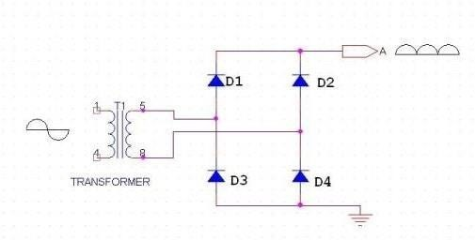

**Figure 5.6 Bridge Rectifier**

As the name suggests it converts the full wave i.e. both the positive & the negative half cycle into DC thus it is much more efficient than Half Wave Rectifier & that too without using a center tapped transformer thus much more cost effective than Full Wave Rectifier.

Full Bridge Wave Rectifier consists of four diodes namely D1, D2, D3 and D4. During the positive half cycle diodes D1 & D4 conduct whereas in the negative half cycle diodes D2 & D3 conduct thus the diodes keep switching the transformer connections so we get positive half cycles in the output. If we use a center tapped transformer for a bridge rectifier, we can get both positive & negative half cycles which can thus be used for generating fixed positive & fixed negative voltages.

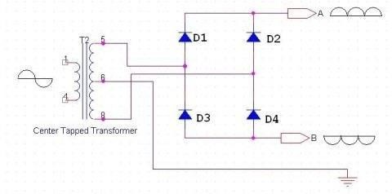

### Figure 5.7 Filter Capacitor

* + 1. **FILTER CAPACITOR**

Even though half wave & full wave rectifier give DC output, none of them provides a constant output voltage. For this we require to smoothen the waveform received from the rectifier. This can be done by using a capacitor at the output of the rectifier this capacitor is also called as “FILTER CAPACITOR” or “SMOOTHING CAPACITOR” or “RESERVOIR CAPACITOR”. Even after

using this capacitor a small amount of ripple will remain.

We place the Filter Capacitor at the output of the rectifier the capacitor will charge to the peak voltage during each half cycle then will discharge its stored energy slowly through the load while the rectified voltage drops to zero, thus trying to keep the voltage as constant as possible.

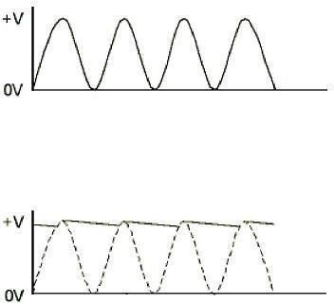

### Figure 5.8 Waveform

If we go on increasing the value of the filter capacitor then the Ripple will decrease. But then the costing will increase. The value of the Filter capacitor depends on the current consumed by the circuit, the frequency of the waveform & the accepted ripple.



Where,

Vr= accepted ripple voltage.( should not be more than 10% of the voltage) I= current consumed by the circuit in Amperes.

F= frequency of the waveform. A half wave rectifier has only one peak in one cycle so F=25hz Whereas a full wave rectifier has Two peaks in one cycle so F=100hz.

### VOLTAGE REGULATOR

A Voltage regulator is a device which converts varying input voltage into a constant regulated output voltage. Voltage regulator can be of two types

1. Linear Voltage Regulator

Also called as Resistive Voltage regulator because they dissipate the excessive voltage resistively as heat.

1. Switching Regulators.

They regulate the output voltage by switching the Current ON/OFF very rapidly. Since their output is either ON or OFF it dissipates very low power thus achieving higher efficiency as compared to linear voltage regulators. But they are more complex & generate high noise due to their switching action. For low level of output power switching regulators tend to be costly but for higher output wattage they are much cheaper than linear regulators.

The most commonly available Linear Positive Voltage Regulators are the 78XX series where the XX indicates the output voltage. And 79XX series is for Negative Voltage Regulators.

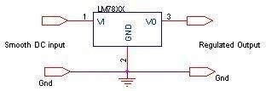

### Figure 5.9 Voltage Regulator

After filtering the rectifier output the signal is given to a voltage regulator. The maximum input voltage that can be applied at the input is 35V.Normally there is a 2-3 Volts drop across the regulator so the input voltage should be at least 2-3 Volts higher than the output voltage. If the input voltage gets below the Vmin of the regulator due to the ripple voltage or due to any other reason the voltage regulator will not be able to produce the correct regulated voltage.

### CIRCUIT DIAGRAM OF POWER SUPPLY

**Figure 5.10 Power Supply Circuit Diagram**

**IC 7805:**

7805 is an integrated three-terminal positive fixed linear voltage regulator. It supports an input voltage of 10 volts to 35 volts and output voltage of 5 volts. It has a current rating of 1 amp although lower current models are available. Its output voltage is fixed at 5.0V. The 7805 also has a built- in current limiter as a safety feature.

|  |  |
| --- | --- |
| **SPECIFICATIONS** | **IC 7805** |
| Vout | 5V |
| Vein - Vout Difference | 5V - 20V |
| Operation Ambient Temp | 0 - 125°C |
| Output Imax | 1A |

* 1. **ARDUINO (MICRO CONTROLLER)**

### INTRODUCTION TO ARDUINO BOARD

The Arduino is a family of microcontroller boards to simplify electronic design, prototyping and experimenting for artists, hackers, hobbyists, but also many professionals. People use it as brains for their robots, to build new digital music instruments, or to build a system that lets your house plants tweet you when they’re dry. Arduinos (we use the standard Arduino Uno) are built around an Atmega microcontroller — essentially a complete computer with CPU, RAM, Flash memory, and input/output pins, all on a single chip. Unlike, say, a Raspberry Pi, it’s designed to attach all kinds of sensors, LEDs, small motors and speakers, servos, etc. directly to these pins, which can read in or output digital or analog voltages between 0 and 5 volts. The Arduino connects to your

computer via USB, where you program it in a simple language (C/C++, similar to Java) from inside the free Arduino IDE by uploading your compiled code to the board. Once programmed, the Arduino can run with the USB link back to your computer, or stand-alone without it — no keyboard or screen needed, just power.

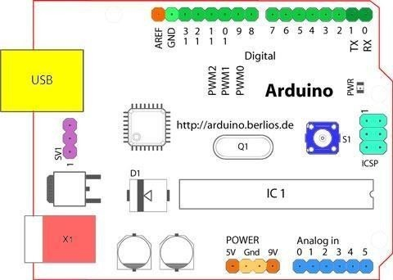

### Figure 5.11 Structure of Arduino Board

Looking at the board from the top down, this is an outline of what you will see (parts of the board you might interact with in the course of normal use are highlighted)

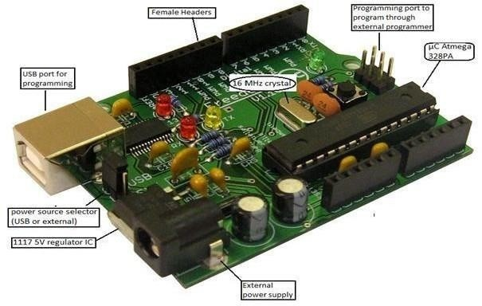

### Figure 5.12 Arduino Board

Starting clockwise from the top center:

* Analog Reference pin (orange)
* Digital Ground (light green)
* Digital Pins 2-13 (green)
* Digital Pins 0-1/Serial In/Out - TX/RX (dark green) - These pins cannot be used for digital i/o (Digital Read and Digital Write) if you are also using serial communication (e.g. Serial.begin).
* Reset Button - S1 (dark blue)
* In-circuit Serial Programmer (blue-green)
* Analog In Pins 0-5 (light blue)
* Power and Ground Pins (power: orange, grounds: light orange)
* External Power Supply In (9-12VDC) - X1 (pink)
* Toggles External Power and USB Power (place jumper on two pins closest to desired supply) - SV1 (purple)
* USB (used for uploading sketches to the board and for serial communication between the board and the computer; can be used to power the board) (yellow)

### DIGITAL PINS

In addition to the specific functions listed below, the digital pins on an Arduino board can be used for general purpose input and output via the [pin Mode(),](http://arduino.cc/en/Reference/PinMode) [Digital Read()](http://arduino.cc/en/Reference/DigitalRead), and [Digital Write()](http://arduino.cc/en/Reference/DigitalWrite) commands. Each pin has an internal pull-up resistor which can be turned on and off using digital Write() (w/ a value of HIGH or LOW, respectively) when the pin is configured as an input. The maximum current per pin is 40mA.

* **Serial: 0 (RX) and 1 (TX).** Used to receive (RX) and transmit (TX) TTL serial data. On the Arduino Diecimila, these pins are connected to the corresponding pins of the FTDI USB-to- TTL Serial chip. On the Arduino BT, they are connected to the corresponding pins of the WT11 Bluetooth module. On the Arduino Mini and LilyPad Arduino, they are intended for use with an external TTL serial module (e.g. the Mini-USB Adapter).
* **External Interrupts: 2 and 3.** These pins can be configured to trigger an interrupt on a low value, a rising or falling edge, or a change in value. See the [attach Interrupt()](http://arduino.cc/en/Reference/AttachInterrupt) function for details.
* **PWM: 3, 5, 6, 9, 10, and 11** Provide 8-bit PWM output with the [analog Write()](http://arduino.cc/en/Reference/AnalogWrite) function. On boards with an ATmega8, PWM output is available only on pins 9, 10, and 11.
* **BT Reset: 7.** (Arduino BT-only) Connected to the reset line of the bluetooth module.
* **SPI: 10 (SS), 11 (MOSI), 12 (MISO), 13 (SCK).** These pins support SPI communication, which, although provided by the underlying hardware, is not currently included in the Arduino language.
* **LED: 13.** On the Diecimila and LilyPad, there is a built-in LED connected to digital pin

13. When the pin is HIGH value, the LED is on, when the pin is LOW, it's off.

### ANALOG PINS

In addition to the specific functions listed below, the analog input pins support 10-bit analog-to- digital conversion (ADC) using the [analog Read()](http://arduino.cc/en/Reference/AnalogRead) function. Most of the analog inputs can also be used as digital pins: analog input 0 as digital pin 14 through analog input 5 as digital pin 19. Analog inputs 6 and 7 (present on the Mini and BT) cannot be used as digital pins.

* **I2C: 4 (SDA) and 5 (SCL).** Support I2C (TWI) communication using the [Wire library](http://wiring.org.co/reference/libraries/Wire/index.html) (documentation on the Wiring website).

### POWER PINS

* **VIN** (sometimes labeled "9V"): The input voltage to the Arduino board when it's using an external power source (as opposed to 5 volts from the USB connection or other regulated power source). You can supply voltage through this pin, or, if supplying voltage via the power jack, access it through this pin. Also note that the Lily Pad has no VIN pin and accepts only a regulated input.
* **5V:** The regulated power supply used to power the microcontroller and other components on the board. This can come either from VIN via an on-board regulator, or be supplied by USB or another regulated 5V supply.
* **3V3** (Diecimila-only) : A 3.3 volt supply generated by the on-board FTDI chip.
* **GND:** Ground pins.

### OTHER PINS

* **AREF:** Reference voltage for the analog inputs. Used with [analog Reference](http://arduino.cc/en/Reference/AnalogReference)().
* **Reset:** (Diecimila-only) Bring this line LOW to reset the microcontroller. Typically used to add a reset button to shields which block the one on the board.

The Port A output buffers have symmetrical drive characteristics with both high sink and source capability. When pins PA0 to PA7 are used as inputs and are externally pulled low, they will source current if the internal pull-up resistors are activated. The Port A pins are tri-stated when a reset condition becomes active, even if the clock is not running.

### PIN DIAGRAM

**Figure 5.13 Pin Configuration of Atmega 328**

**Pin Description**

VCC: Digital supply voltage. GND: Ground. Port A (PA7-PA0):

Port A serves as the analog inputs to the A/D Converter. Port A also serves as an 8-bit bi- directional I/O port, if the A/D Converter is not used. Port pins can provide internal pull-up resistors (selected for each

Port B

Port B is an 8-bit bi-directional I/O port with internal pull-up resistors (selected for each bit). The Port B output buffers have symmetrical drive characteristics with both high sink and source capability. As inputs, Port B pins that are externally pulled low will source current if the pull-up resistors are activated. The Port B pins are tri-stated when a reset condition becomes active, even if the clock is not running. Port B also serves the functions of various special features of the

ATmega32.

### Port C (PC7-PC0):

Port C is an 8-bit bi-directional I/O port with internal pull-up resistors (selected for each bit). The Port C output buffers have symmetrical drive characteristics with both high sink and source capability. As inputs, Port C pins that are externally pulled low will source current if the pull-up resistors are activated. The Port C pins are tri-stated when a reset condition becomes active, even if the clock is not running. If the JTAG interface is enabled, the pull-up resistors on pins PC5(TDI), PC3(TMS) and PC2(TCK) will be activated even if a reset occurs. The TD0 pin is tri- stated unless TAP states that shift out data are entered. Port C also serves the functions of the JTAG interface. **Port D (PD7-PD0):**

Port D is an 8-bit bi-directional I/O port with internal pull-up resistors (selected for each bit). The Port D output buffers have symmetrical drive characteristics with both high sink and source capability. As inputs, Port D pins that are externally pulled low will source current if the pull-up resistors are activated. The Port D pins are tri-stated when a reset condition becomes active, even if the clock is not running. Port D also serves the functions of various special features of the ATmega32.

### Reset (Reset Input):

A low level on this pin for longer than the minimum pulse length will generate a reset, even if the clock is not running. Shorter pulses are not guaranteed to generate a reset.

XTAL1: Input to the inverting Oscillator amplifier and input to the internal clock operating circuit. XTAL2: Output from the inverting Oscillator amplifier.

AVCC: AVCC is the supply voltage pin for Port A and the A/D Converter. It should be externally connected to VCC, even if the ADC is not used. If the ADC is used, it should be connected to VCC through a low-pass filter.

AREF: AREF is the analog reference pin for the A/D Converter.

### Features

* 1.8-5.5V operating range
* Up to 20MHz
* Part: ATMEGA328P-AU
* 32kB Flash program memory
* 1kB EEPROM
* 2kB Internal SRAM
* 2 8-bit Timer/Counters
* 16-bit Timer/Counter
* RTC with separate oscillator
* Master/Slave SPI interface
* 2-wire (I2C) interface
* Watchdog timer
* 23 IO lines

### AVR CPU Core

The AVR core combines a rich instruction set with 32 general purpose working registers. All the 32 registers are directly connected to the Arithmetic Logic Unit (ALU), allowing two independent registers to be accessed in one single instruction executed in one clock cycle. The resulting architecture is more code efficient while achieving throughputs up to ten times faster than conventional CISC microcontrollers.

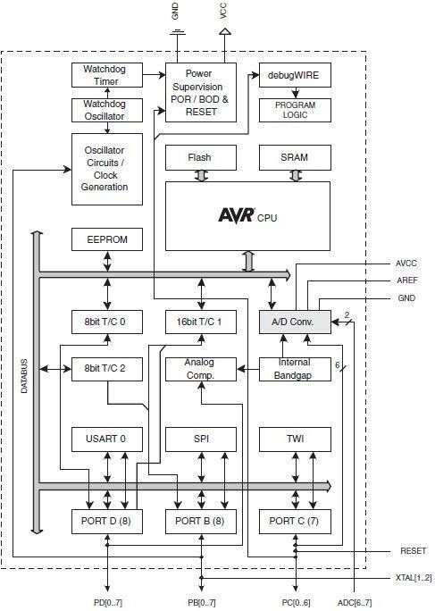

### Figure 5.14 AVR Block Diagram

**OVERVIEW**

This section discusses the AVR core architecture in general. The main function of the CPU core is to ensure correct program execution. The CPU must therefore be able to access memories, perform calculations, control peripherals, and handleinterrupts. In order to maximize performance and parallelism, the AVR uses a Harvard architecture – with separate memories and buses for program and data

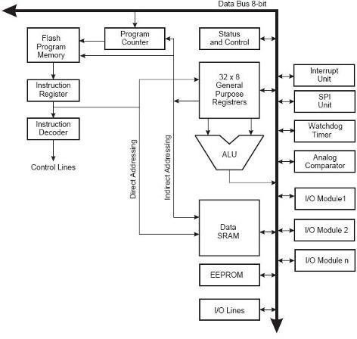

### Figure 5.15 AVR Architecture

Instructions in the program memory are executed with a single level pipelining. While one instruction is being executed, the next instruction is pre-fetched from the program memory. This concept enables instructions to be executed in every clock cycle. The program memory is In- System Reprogrammable Flash memory. The fast-access Register File contains 32 x 8-bitgeneral purpose working registers with a single clock cycle access time. This allows single-cycle Arithmetic Logic Unit (ALU) operation. In a typical ALU operation, two operands are output from the Register File, the operation is executed, and the result is stored back in the Register File– in one clock cycle.

Six of the 32 registers can be used as three 16-bit indirect address register pointers for Data Space addressing – enabling efficient address calculations. One of these address pointers can also be used as an address pointer for look up tables in Flash program memory These added function registers are the 16-bit X-, Y-, and Z-register, described later in this section.

### ARDUINO CHARACTERISTICS

#### Power

The Arduino Uno can be powered via the USB connection or with an external power supply. The power source is selected automatically. External (non-USB) power can come either from an AC- to-DC adapter (wall-wart) or battery. The adapter can be connected by plugging a 2.1mm center- positive plug into the board's power jack.

Leads from a battery can be inserted in the Gnd and Vin pin headers of the POWER connector. The board can operate on an external supply of 6 to 20 volts.

If supplied with less than 7V, however, the 5V pin may supply less than five volts and the board may be unstable. If using more than 12V, the voltage regulator may overheat and damage the board. The recommended range is 7 to 12 volts.

#### The power pins are as follows:

* **VIN:** The input voltage to the Arduino board when it's using an external power source (as opposed to 5 volts from the USB connection or other regulated power source). You can supply voltage through this pin, or, if supplying voltage via the power jack, access it through this pin.
* **5V:** This pin outputs a regulated 5V from the regulator on the board.
* The board can be supplied with power either from the DC power jack (7 - 12V),
* the USB connector (5V), or the VIN pin of the board (7-12V). Supplying voltage via the 5V or 3.3V pins bypasses the regulator, and can damage your board. We don't advise it.
* **3V3.** A 3.3 volt supply generated by the on-board regulator. Maximum current draw is 50 mA.
* **GND.** Ground pins.
* **IOREF.** This pin on the Arduino board provides the voltage reference with which the microcontroller operates.
* A properly configured shield can read the IOREF pin voltage and select the appropriate power source or enable voltage translators on the outputs for working with the 5V or 3.3V.

#### Memory:

The ATmega328 has 32 KB (with 0.5 KB used for the boot loader). It also has 2 KB of SRAM and 1 KB of EEPROM (which can be read and written with the [EEPROM library](http://www.arduino.cc/en/Reference/EEPROM)).

Serial Communication:

The Arduino Uno has a number of facilities for communicating with a computer, another Arduino, or other microcontrollers. The ATmega328 provides UART TTL (5V) serial communication, which is available on digital pins 0 (RX) and 1 (TX). An ATmega16U2 on the board channels this serial communication over USB and appears as a virtual com port to software on the computer. The '16U2 firmware uses the standard USB COM drivers, and no external driver is needed. However, [on Windows, a .inf file is required.](http://arduino.cc/en/Guide/Windows#toc4) The Arduino software includes a serial monitor which allows simple textual data to be sent to and from the Arduino board. The RX and TX LEDs on the board will flash when data is being transmitted via the USB-to-serial chip and USB connection to the computer (but not for serial communication on pins 0 and 1).

A Software Serial library allows for serial communication on any of the Uno's digital pins. The ATmega328 also supports I2C (TWI) and SPI communication. The Arduino software includes a Wire library to simplify use of the I2C bus. For SPI communication, use the [SPI library](http://arduino.cc/en/Reference/SPI).

## ARDUINO WITH ATMEGA 328

The Arduino Uno is a microcontroller board based on the ATmega328 (datasheet). It has 14 digital input/output pins (of which 6 can be used as PWM outputs), 6 analog inputs, a 16 MHz ceramic resonator, a USB connection, a power jack, an ICSP header, and a reset button. It contains everything needed to support the microcontroller; simply connect it to a computer with a USB cable or power it with a AC-to-DC adapter or battery to get started.

* Pin out: Added SDA and SCL pins that are near to the AREF pin and two other new pins placed near to the RESET pin, the IOREF that allow the shields to adapt to the voltage provided from the board. In future, shields will be compatible with both the board that uses the AVR, which operates with 5V and with the Arduino. Due that operates with 3.3V. The second one is a not connected pin that is reserved for future purposes.
* Stronger RESET circuit.
* Atmega 16U2 replace the 8U2.

## ELECTROMAGNETIC RELAY

Relay is an electromagnetic switch. . It consists of a coil of wire surrounding a soft iron core, an iron yoke, which provides a low reluctance path for magnetic flux, a movable iron armature, and a set, or sets, of contacts; two in the relay pictured.

The armature is hinged to the yoke and mechanically linked to a moving contact or contacts. When an electric current is passed through the coil, the resulting magnetic field attracts the armature and the consequent movement of the movable contact or contacts either makes or breaks a connection with a fixed contact. 4-channel universal relay card works as switch).

Arduino microcontroller controls the relay card there by switching of two motors. It triggers the relays such that the panel rotates to achieve maximum output power.

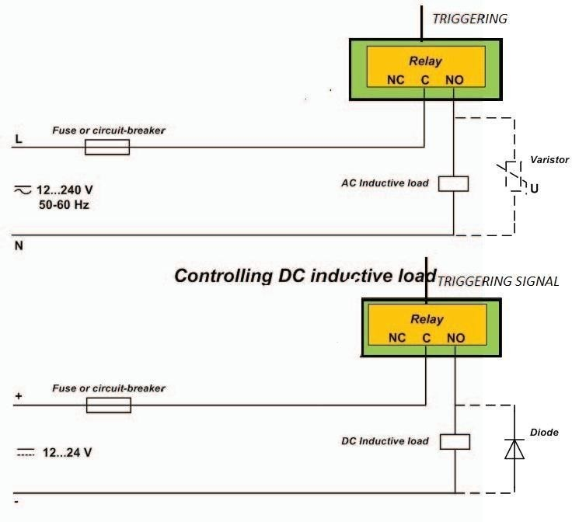

### Figure 5.16 Electro Magnetic Relay

* 1. **SERVO MOTOR**

Servomotors are designed to operate control surfaces on hobby RC planes. So they do not rotate continuously. Rather they are designed to rotate through 180 degrees with precise position control. If you want to use them as the main drive motor for a mobile robot you need to modify them so that they will rotate continuously. This is not a difficult thing to do. you will not cover it here but if you want to do it there are many sites on the web that cover this.

A servomotor is controlled by sending a pulse signal that is HIGH for a brief time, generally 1

– 2 ms. If you just connect a battery to power and ground, nothing will happen. You must have a timer circuit that generates this pulsed signal and by varying the pulse ON time (or thepulse width) the motor will move to a certain position over its range of motion and then stop as long as the input pulse width is the same. Depending on the pulse width, you’ll get a different position.

### ADVANTAGES

* Automatic controlling of wiper using Servo motor.
* Automatic rain and moisture detection using sensor.
* Highly efficient and low-cost design
* 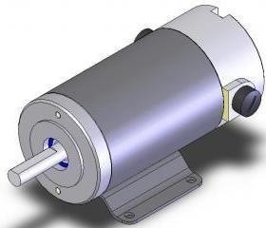Low power consumption

### Figure 5.17 Servo Motor

* 1. **LIGHT DEPENDENT RESISTOR**
* LDR sensors detect the light intensity of the sun. Arduino compares the analog output values of LDRs. When A1 value is greater than A2, digital pin 4 of Arduino becomes high.
* This actuates relay 1 which in turn energises motor 1. There by motor 1 rotates the panel in the forward direction by a given angle in azimuth direction. Whereas, when A2 value is greater than

the value of A1, digital pin 5 of Arduino becomes high.

* This actuates relay 2 which in turn energises motor 1. There by motor 1 rotates the panel in the reverse direction by a given angle in azimuth direction.
* Arduino components the analog output values of A3,A4 from LDRs when A3 value is greater than A4, digital pin6 of Arduino becomes HIGH the actuates relay 3 of relay card
* Then motor 2 rotates the solar panel in the forward direction bya given angle in altitude direction When the value of A4 is greater than the value of A4 is greater the value of A5 digital pin 7 of Arduino becomes HIGH this will actuates relay
* This will actuates relay 4 of relay card. Motor 2 rotates the solar panel in the reverse direction by a given angle in altitude direction.
* Whenever LDRs unable to detect the sun’s positiondue to cloudy days (light intensity in active hours is less than minimum limit) timer gets activated automatically and control the tracking as per the time instant.
* Thus the solar panels are made to align them self perpendicularly to sun rays, to maximize the output energy

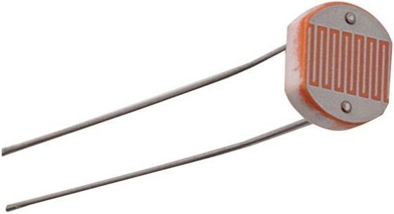

### Figure 5.18 Light Dependent Resistor (LDR)

* 1. **SOLAR PANEL**

Renewable energy is critical to our fight against climate change. We simply must shift our world to a low-carbon economy and away from oil and coal. Experts agree we need a substantial reduction in CO2 over the next 40-50 years and this means we need renewable energy to replace fossil fuels now. Presently, most of the energy what we are using is from nonrenewable sources like petrol, coal etc.., which are very limited. Apart from the non-renewable energy sources, renewable energy sources like wind energy, solar energy etc.., are used then we can save non- renewable sources for longer time.

### ADVANTAGES

* A solar cell (also called photovoltaic cell) is a solid state device that converts the energy of sunlight directly into electricity by the photovoltaic effect.
* Assemblies of cells are used to make solar modules, also known as solar panels.
* The energy generated from these solar modules, referred to as solar power, is an example of solar energy.
* It does not cause any environmental pollution like the fossil fuels and nuclear power.
* Solar cells last a longer time and have low running costs
* Low power consumption.
* Conservation of energy.



### Figure 5.19 Solar Panel

* 1. **RAIN SENSOR**

A rain sensor or rain switch is a switching device activated by rainfall. There are two main applications for rain sensors. The first is a water conservation device connected to an automatic irrigation system that causes the system to shut down in the event of rainfall. The second is a device used to protect the interior of an automobile from rain and to support the automatic mode of windscreen wipers. An additional application in professional satellite communications antennas is to trigger a rain blower on the aperture of the antenna feed, to remove water droplets from the mylar cover that keeps pressurized and dry air inside the wave-guides.

Rain sensors for irrigation systems are available in both wireless and hard-wired versions, most employing hygroscopic disks that swell in the presence of rain and shrink back down again as they dry out — an electrical switch is in turn depressed or released by the hygroscopic disk stack, and the rate of drying is typically adjusted by controlling the ventilation reaching the stack. However, some electrical type sensors are also marketed that use tipping bucket or conductance type probes to measure rainfall. Wireless and wired versions both use similar mechanisms to temporarily suspend watering by the irrigation controller — specifically they are connected to the irrigation

controller's sensor terminals, or are installed in series with the solenoid valve common circuit such that they prevent the opening of any valves when rain has been sensed.

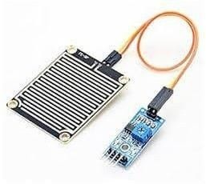

### Figure 5.20 Rain Sensor

* 1. **TEMPERATURE SENSOR (LM35)**

The LM35 sensor series are precision integrated-circuit temperature sensors, whose output voltage is linearly proportional to the Celsius (Centigrade) temperature. The LM35 series are precision integrated-circuit LM35 temperature sensors, whose output voltage is linearly proportional to the Celsius (Centigrade) temperature. The LM35 sensor thus has an advantage over linear temperature sensors calibrated in ° Kelvin, as the user is not required to subtract a large constant voltage from its output to obtain convenient Centigrade scaling.

The LM35 sensor does not require any external calibration or trimming to provide typical accuracies of ±¼°C at room temperature and ±¾°C over a full -55 to +150°C temperature range. Low cost is assured by trimming and calibration at the wafer level. The LM35's low output impedance, linear output, and precise inherent calibration make interfacing to readout or control circuitry especially easy.

It can be used with single power supplies, or with plus and minus supplies. As it draws only 60

µA from its supply, it has very low self-heating, less than 0.1°C in still air. The LM35 is rated to operate over a -55° to +150°C temperature range, while the LM35C sensor is rated for a -40° to

+110°C range (-10° with improved accuracy).The LM35 series is available packaged in hermetic TO-46 transistor packages, while the LM35C, LM35CA, and LM35D are also available in the plastic TO-92 transistor package. The LM35D sensor is also available in an 8-lead surface mount small outline package and a plastic TO-220 package.

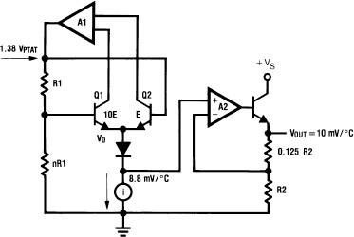

### Figure 5.21 Circuit Diagram of LM35

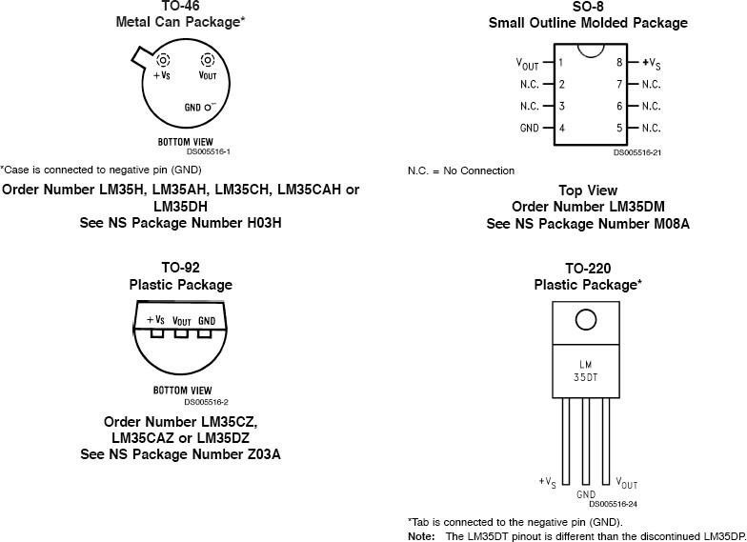

**Figure 5.22 LM 35 Pinouts and Packaging**

* + 1. **LM35 SENSOR SOURCES**

There are several manufacturers of this popular part and each has LM35 sensor specs, datasheets and other free LM35 downloads. This amplifier is available from the following manufacturers.

* National Semiconductor
* On Semiconductor
* Texas Instruments
* Fairchild Semiconductor
* STMicroelectronics
* Jameco Electronics
* Analog Devices

### LM35 SENSOR AND BACKGROUND APPLICATION

Most commonly-used electrical temperature sensors are difficult to apply. For example, thermocouples have low output levels and require cold junction compensation. Thermistors are nonlinear. In addition, the outputs of these sensors are not linearly proportional to any temperature scale. Early monolithic sensors, such as the LM3911, LM134 and LM135, overcame many of these difficulties, but their outputs are related to the Kelvin temperature scale rather than the more popular Celsius and Fahrenheit scales. Fortunately, in 1983 two I.C.’s, the LM34 Precision Fahrenheit Temperature Sensor and the LM35 Precision Celsius Temperature Sensor, were introduced. This application note will discuss the LM34, but with the proper scaling factors can easily be adapted to the LM35.

The LM35/LM34 has an output of 10 mV/°F with a typical nonlinearity of only ±0.35°F over a

−50 to +300°F temperature range, and is accurate to within ±0.4°F typically at room temperature (77°F). The LM34’s low output impedance and linear output characteristic make interfacing with readout or control circuitry easy. An inherent strength of the LM34 sensor over other currently available temperature sensors is that it is not as susceptible to large errors in its output from low level leakage currents. For instance, many monolithic temperature sensors have an output of only 1 μA/°K. This leads to a 1°K error for only 1 μ-Ampere of leakage current. On the other hand, the LM34 sensor may be operated as a current mode device providing 20 μA/°F of output current. The same 1 μA of leakage current will cause an error in the LM34’s output of only 0.05°F (or 0.03°K after scaling).

Low cost and high accuracy are maintained by performing trimming and calibration procedures at the wafer level. The device may be operated with either single or dual supplies. With less than 70 μA of current drain, the LM34 sensor has very little self-heating (less than 0.2°F in still air), and comes in a TO-46 metal can package, a SO-8 small outline package and a TO-92 plastic package. The LM35/LM34 is a versatile device which may be used for a wide variety of applications, including oven controllers and remote temperature sensing. The device is easy to use (there are only three terminals) and will be within 0.02°F of a surface to which it is either glued or cemented.

## LCD MODULE

To display interactive messages we are using LCD Module. We examine an intelligent LCD display of two lines,16 characters per line that is interfaced to the controllers. The protocol (handshaking) for the display is as shown. Whereas D0 to D7th bit is the Data lines, RS, RW and EN pins are the control pins and remaining pins are +5V, -5V and GND to provide supply. Where RS is the Register Select, RW is the Read Write and EN is the Enable pin.

The display contains two internal byte-wide registers, one for commands (RS=0) and the second for characters to be displayed (RS=1). It also contains a user-programmed RAM area (the character RAM) that can be programmed to generate any desired character that can be formed using a dot matrix. To distinguish between these two data areas, the hex command byte 80 will be used to signify that the display RAM address 00h will be chosen.Port1 is used to furnish the command or data type, and ports 3.2 to3.4 furnish register select and read/write levels.

The display takes varying amounts of time to accomplish the functions as listed. LCD bit 7 is monitored for logic high (busy) to ensure the display is overwritten. Liquid Crystal Display also called as LCD is very helpful in providing user interface as well as for debugging purpose. The most common type of LCD controller is HITACHI 44780 which provides a simple interface between the controller & an LCD. These LCD's are very simple to interface with the controller as well as are cost effective.

The most commonly used *ALPHANUMERIC* displays are *1x16* (Single Line & 16 characters), *2x16* (Double Line & 16 character per line) & *4x20* (four lines & Twenty characters per line). The LCD requires 3 control lines (RS, R/W & EN) & 8 (or 4) data lines. The number on data lines depends on the mode of operation. If operated in 8-bit mode then 8 data lines + 3 control lines i.e. total 11 lines are required. And if operated in 4-bit mode then 4 data lines + 3 control lines i.e. 7 lines are required. How do we decide which mode to use? It’s simple if you have sufficient data lines you can go for 8 bit mode & if there is a time constrain i.e. display should be faster then we have to use 8-bit mode because basically 4-bit mode takes twice as more time as compared to 8- bit mode. When *RS* is low (0), the data is to be treated as a command. When RS is high (1), the data being sent is considered as text data which should be displayed on the screen.

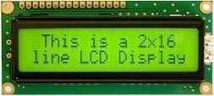

### Figure 5.23 2X16 Line Alphanumeric LCD Display

When *R/W* is low (0), the information on the data bus is being written to the LCD. When RW is high (1), the program is effectively reading from the LCD. Most of the times there is no need to read from the LCD so this line can directly be connected to Gnd thus saving one controller line. The *ENABLE* pin is used to latch the data present on the data pins. A HIGH - LOW signal is required to latch the data. The LCD interprets and executes our command at the instant the EN line is brought low. If you never bring EN low, your instruction will never be executed.

|  |  |  |
| --- | --- | --- |
| Pin | Symbol | Function |
| 1 | Vss | Ground |
| 2 | Vdd | Supply Voltage |
| 3 | Vo | Contrast Setting |
| 4 | RS | Register Select |
| 5 | R/W | Read/Write Select |
| 6 | En | Chip Enable Signal |
| 7-14 | DB0-DB7 | Data Lines |
| 15 | A/Vee | Gnd for the backlight |
| 16 | K | Vcc for backlight |

### Table 5.1 LCD Modul

* + 1. **COMMANDS USED IN LCD**

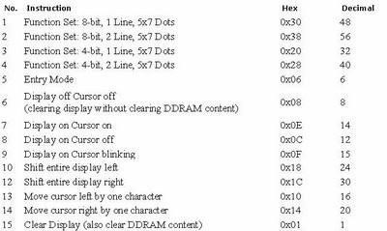

**Table 5.2 Basic 16x 2 Characters LCD - Black on Green 5V:**

* + 1. **LCD DESCRIPTION**

This is a basic 16 character by 2 line display. Black text on Green background. Utilizes the extremely common HD44780 parallel interface chipset. Interface code is freely available. We will need ~11 general I/O pins to interface to this LCD screen. **Includes LED backlight.** The most commonly used LCDs found in the market today are 1 Line, 2 Line or 4 Line LCDs which have only 1 controller and support at most of 80 characters, whereas LCDs supporting more than 80

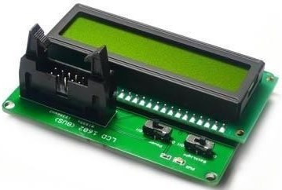

### Figure 5.24 LED Backlight

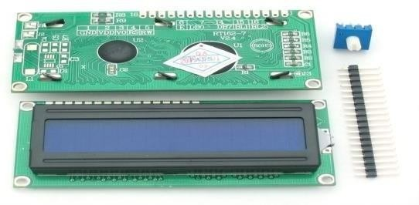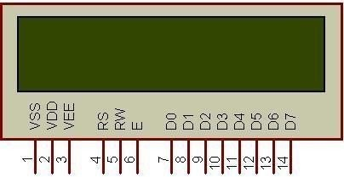

**Figure 5.25 Shows LCD Pin Diagrams**

* + 1. **PIN DESCRIPTION**

|  |  |  |
| --- | --- | --- |
| **Pin No.** | **Name** | **Description** |
| Pin no. 1 | **VSS** | Power supply (GND) |
| Pin no. 2 | **VCC** | Power supply (+5V) |
| Pin no. 3 | **VEE** | Contrast adjust |
| Pin no. 4 | **RS** | 0 = Instruction input 1 = Data input |
| Pin no. 5 | **R/W** | 0 = Write to LCD module  1 = Read from LCD module |
| Pin no. 6 | **EN** | Enable signal |
| Pin no. 7 | **D0** | Data bus line 0 (LSB) |
| Pin no. 8 | **D1** | Data bus line 1 |
| Pin no. 9 | **D2** | Data bus line 2 |
| Pin no. 10 | **D3** | Data bus line 3 |
| Pin no. 11 | **D4** | Data bus line 4 |
| Pin no. 12 | **D5** | Data bus line 5 |
| Pin no. 13 | **D6** | Data bus line 6 |
| Pin no. 14 | **D7** | Data bus line 7 (MSB) |

**Table 5.3 Character of LCD Pin Controller 1**

**TABLE 5.4 CHARACTER OF LCD PIN CONTROLLER 2**

|  |  |  |
| --- | --- | --- |
| **Pin No.** | **Name** | **Description** |
| Pin no. 1 | **D7** | Data bus line 7 (MSB) |
| Pin no. 2 | **D6** | Data bus line 6 |
| Pin no. 3 | **D5** | Data bus line 5 |
| Pin no. 4 | **D4** | Data bus line 4 |
| Pin no. 5 | **D3** | Data bus line 3 |
| Pin no. 6 | **D2** | Data bus line 2 |
| Pin no. 7 | **D1** | Data bus line 1 |
| Pin no. 8 | **D0** | Data bus line 0 (LSB) |
| Pin no. 9 | **EN1** | Enable signal for row 0 and 1 (1stcontroller) |
| Pin no. 10 | **R/W** | 0 = Write to LCD module 1 = Read from LCD module |
| Pin no. 11 | **RS** | 0 = Instruction input 1 = Data input |
| Pin no. 12 | **VEE** | Contrast adjust |
| Pin no. 13 | **VSS** | Power supply (GND) |
| Pin no. 14 | **VCC** | Power supply (+5V) |
| Pin no. 15 | **EN2** | Enable signal for row 2 and 3 (2ndcontroller) |
| Pin no. 16 | **NC** | Not Connected |

* + 1. **LCD BACKGROUND**

Frequently, an 8051 program must interact with the outside world using input and output devices that communicate directly with a human being. One of the most common devices attached to an 8051 is an LCD display. Some of the most common LCDs connected to the 8051 are 16x2 and 20x2 displays. This means 16 characters per line by 2 lines and 20 characters per line by 2 lines, respectively.

### 44780 Background:

The 44780 standard requires 3 control lines as well as either 4 or 8 I/O lines for the data bus. The user may select whether the LCD is to operate with a 4-bit data bus or an 8-bit data bus. If a 4-bit data bus is used the LCD will require a total of 7 data lines (3 control lines plus the 4 lines for the data bus). If an 8-bit data bus is used the LCD will require a total of 11 data lines (3 control lines plus the 8 lines for the data bus). The three control lines are referred to as **EN**, **RS**, and **RW**.

The **EN** line is called "Enable." This control line is used to tell the LCD that we are sending it data. To send data to the LCD, our program should make sure this line is low (0) and then set the other two control lines and/or put data on the data bus. When the other lines are completely ready, bring **EN** high (1) and wait for the minimum amount of time required by the LCD datasheet (this varies from LCD to LCD), and end by bringing it low (0) again.

The **RS** line is the "Register Select" line. When RS is low (0), the data is to be treated as a command or special instruction (such as clear screen, position cursor, etc.). When RS is high (1), the data being sent is text data which should be displayed on the screen. For example, to display the letter "T" on the screen we would set RS high.

The **RW** line is the "Read/Write" control line. When RW is low (0), the information on the data bus is being written to the LCD. When RW is high (1), the program is effectively querying (or reading) the LCD. Only one instruction ("Get LCD status") is a read command. All others are write commands--so RW will almost always be low.Finally, the data bus consists of 4 or 8 lines (depending on the mode of operation selected by the user). In the case of an 8-bit data bus, the lines are referred to as DB0, DB1, DB2, DB3, DB4, DB5, DB6, and DB7.

### Interfacing Example - 16 Characters x 2 Lines LCD:

This is the first interfacing example for the Parallel Port. We will start with something simple. This example doesn't use the Bi-directional feature found on newer ports, thus it should work with most, if no all Parallel Ports. It however doesn't show the use of the Status Port as an input. A 16 Character x 2 Line LCD Module to the Parallel Port. These LCD Modules are very common these days, and are quite simple to work with, as all the logic required running them is on board.

### CIRCUIT DESCRIPTION

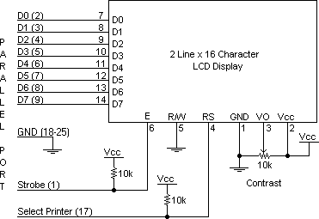

**Figure 5.26 Shows LCD Circuit Description**

Above is the quite simple schematic. The LCD panel's Enable and Register Select is connected to the Control Port. The Control Port is an open collector / open drain output. While most Parallel Ports have internal pull-up resistors, there is a few which don't. Therefore, by incorporating the two 10K external pull up resistors, the circuit is more portable for a wider range of computers, some of which may have no internal pull up resistors.

We make no effort to place the Data bus into reverse direction. Therefore, we hard wire the R/W line of the LCD panel, into write mode. This will cause no bus conflicts on the data lines. As a result we cannot read back the LCD's internal Busy Flag which tells us if the LCD has accepted and finished processing the last instruction. This problem is overcome by inserting known delays into our program.

The 10k Potentiometer controls the contrast of the LCD panel. Nothing fancy here. As with all the examples, I've left the power supply out. We can use a bench power supply set to 5v or use an onboard +5 regulator. Remember a few de-coupling capacitors, especially if we have troublewith the circuit working properly.

### AN EXAMPLE FOR HARDWARE CONFIGURATION

As we've mentioned, the LCD requires either 8 or 11 I/O lines to communicate with. For the sake of this tutorial, we are going to use an 8-bit data bus--so we'll be using 11 of the 8051's I/O pins to

interface with the L

Let's draw a sample pseudo-schematic of how the LCD will be connected to the 8051.

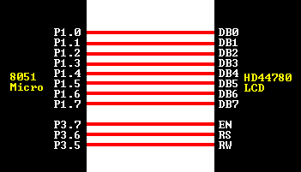

### Figure 5.27 LCD Connections

As we can see, we've established a 1-to-1 relation between a pin on the 8051 and a line on the 44780 LCD. Thus as we write our assembly program to access the LCD, we are going to equate constants to the 8051 ports so that we can refer to the lines by their 44780 name as opposed to P0.1, P0.2, etc. Let's go ahead and write our initial equates:

### CLEARING THE DISPLAY:

When the LCD is first initialized, the screen should automatically be cleared by the 44780 controllers. However, it's always a good idea to do things our self so that we can be completely sure that the display is the way we want it. Thus, it's not a bad idea to clear the screen as the very first operation after the LCD has been initialized.

An LCD command exists to accomplish this function. Not surprisingly, it is the command 01h. Since clearing the screen is a function, we very likely will wish to call more than once, it's a good idea to make it a subroutine:

### CHECKING THE BUSY STATUS OF LCD

As previously mentioned, it takes a certain amount of time for each instruction to be executed by the LCD. The delay varies depending on the frequency of the crystal attached to the oscillator input of the 44780 as well as the instruction which is being executed.

While it is possible to write code that waits for a specific amount of time to allow the LCD to execute instructions, this method of "waiting" is not very flexible. If the crystal frequency is changed, the software will need to be modified. Additionally, if the LCD itself is changed for

another LCD which, although 44780 compatible, requires more time to perform its operations, the program will not work until it is properly modified.

### APPLICATION

* Medical equipment
* Electronic test equipment
* Industrial machinery Interface
* Serial terminal
* Advertising system
* EPOS
* Restaurant ordering systems
* Gaming box
* Security systems
* R&D Test units
* Climatizing units
* PLC Interface
* Simulators
* Environmental monitoring
* Lab development
* Student projects
* Home automation
* PC external display

## 555 TIMER IC

### INTRODUCTION:

The 555 timer IC was first introduced around 1971 by the Signetics Corporation as the SE555/NE555 and was called "The IC Time Machine" and was also the very first and only commercial timer ic available.

It provided circuit designers and hobby tinkerers with a relatively cheap, stable, and user-friendly integrated circuit for both monostable and astable applications. Since this device was first made commercially available, a myrad of novel and unique circuits have been developed and presented in several trade, professional, and hobby publications. The past ten years some manufacturers stopped making these timers because of competition or other reasons. Yet other companies, like [NTE](http://www.nteinc.com/) (a subdivision of Philips) picked up where some left off.

This primer is about this fantastic timer which is after 30 years still very popular and used in many schematics. Although these days the CMOS version of this IC, like the [Motorola](http://www.motorola.com/) MC1455, is

mostly used, the regular type is still available, however there have been many improvements and variations in the circuitry. But all types are pin-for-pin plug compatible.

This timer uses a maze of transistors, diodes and resistors and for this complex reason I will use a more simplified (but accurate) block diagram to explain the internal organizations of the 555.

The 555 timer integrated circuit (IC) has become a mainstay in electronics design. A 555 timer will produce a pulse when a trigger signal is applied to it. The pulse length is determined by charging then discharging a capacitor connected to a 555 timer.

A 555 timer can be used to debounce switches, modulate signals, create accurate clock signals, create pulse width modulated (PWM) signals, etc. A 555 timer can be obtained from various manufacturers including Fairchild Semiconductor and National Semiconductor.

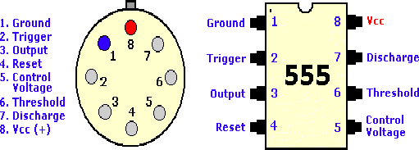

### Figure 5.28 555 Timer 8-Pin T- Package & V-Package

A 555 timer is a semiconductor device that controls various modes of on/off states in electrical systems. The 555 timer is one of the most widely used types of integrated circuits. The 555 in figures above, come in two packages, either the round metal-can called the 'T' package or themore familiar 8-pin DIP 'V' package. About 20-years ago the metal-can type was pretty much the standard (SE/NE types). The 556 timer is a dual 555 version and comes in a 14-pin DIP package, the 558 is a quad version with four 555's also in a 14 pin DIP case

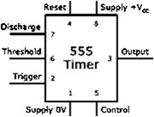

### Figure 5.29 555 Timer Circuit Diagram

* + 1. **PIN DESCRIPTION:**

**Pin 1 (Ground):**

Connects to the 0v power supply Ground connection for chip

### Pin 2 (Trigger):

Detects 1/3 of rail voltage to make output HIGH Pin 2 has control over pin 6. If pin 2 is LOW, and pin 6 LOW, output goes and stays HIGH. If pin 6 HIGH, and pin 2 goes LOW, output goes LOW while pin 2 LOW. This pin has a very high impedance (about 10M) and will trigger with about 1uA. 555 timer triggers when this pin transitions from voltage at Vcc to 33% v voltage at Vcc. Output pin goes high when triggered.

### Pin 3 (Output):

(Pins 3 and 7 are "in phase.") Goes HIGH (about 2v less than rail) and LOW (about 0.5v less than 0v) and will deliver up to 200mA.

### Pin 4 (Reset):

Internally connected HIGH via 100k Must be taken below 0.8v to reset the chip Resets 555 timer when low

### Pin 5 (Control):

Used to change Threshold and Trigger set point voltages and is rarely used A voltage applied to this pin will vary the timing of the RC network (quite considerably).

### Pin 6 (Threshold):

Used to detect when the capacitor has charged The Output pin goes low w when capacitor has charged to 66.6% of Vcc. Detects 2/3 of rail voltage to make output LOW only if pin 2 is HIGH. This pin has a very high impedance (about 10M) and will trigger with about 0.2uA.

### Pin 7 (Discharge):

Goes LOW when pin 6 detects 2/3 rail voltage but pin 2 must be HIGH. If pin 2 is HIGH, pin 6 can be HIGH or LOW and pin 7 remains LOW. Goes OPEN (HIGH) and stays HIGH when pin 2 detects 1/3 rail voltage (even as a LOW pulse) when pin 6 is LOW. (Pins 7 and 3 are "inphase.") Pin 7 is equal to pin 3 but pin 7 does not go high - it goes OPEN. But it goes LOW and will sink about 200mA.

### Pin 8 (Supply):

Connects to the positive power supply (Vs). This can be any voltage between 4.5V and 15V DC, but is commonly 5V DC when working with digital ICs.

# CHAPTER-VI PROGRAMME

## 6.1 Servo Motor Programme

### # include <servo.h>

Servo servo1; Servo servo2; int pos1=0; int pos2=0; int up=0;

int down=0; int right=0; int left=0; int centre=0; int ldr1=0; int ldr2=0; int ldr3=0; int ldr4=0; int ldr5=0; **void setup ()**

### {

servo1.attach(10); servo1.write(90); servo2.attach(9); servo2.write(90);

pinMode(ldr1, INPUT); pinMode(ldr2, INPUT); pinMode(ldr3, INPUT); pinMode(ldr4, INPUT); pinMode(ldr5, INPUT);

### }

**void loop ()**

**{**

pos1=servo1.read(); pos2=servo2.read();

int up= analogRead(ldr1); int down= analogRead(ldr2); int centre= analogRead(ldr3) int right= analogRead(ldr4); int left= analogRead(ldr5);

## //for conrol of vertical i.e. up-down(east-west) position

### if (up>centre << down<centre)

**{**

servo1.write(pos1+1); delay(10);

### }

**else if (down>centre << up<centre)**

**{**

servo1.write(pos1-1); delay(10);

### }

**Else**

**{**

servo1.write(pos1); delay(10);

### }

**//for control of horizontal i.e.right-left (south-north) position**

**if (right>centre << left<centre)**

**{**

servo2.write(pos2+1); delay(10);

### }

**else if (left>centre << right<centre)**

**{**

servo2.write(pos2-1); delay(10);

### }

**Else**

**{**

servo2.write(pos2); delay(10);

### }

**CHAPTER-VII PROJECT RESULTS**

* 1. **EXPERIMENTAL CONFIGURATION**

The proposed system tracks the sun both in azimuth and altitude angles. Two motors wereactuated with the help of electromagnetic relay to provide azimuth and elevation angles based on the received sensor data connected to analog pins A2,A3,A4,A5 OF Arduino. The working algorithm for the proposed dual axis tracking system was as follows

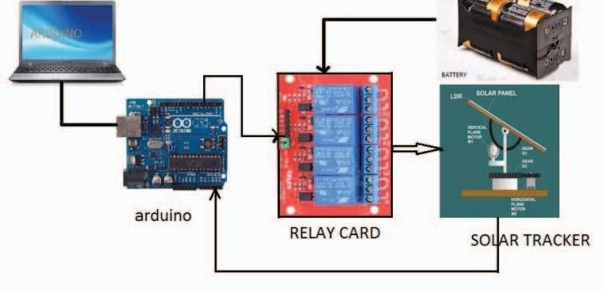

### Figure 7.1 Experimental Configuration of Solar Tracking

Arduino compares the analog output values of A3, A4 from LDRs. when A3 value is greater than A4, digital pin 6 of Arduino becomes HIGH. This actuates relay 3 of relay card.

Then motor 2 rotates the solar panel in the forward direction by a given angle in altitude direction. When the value of A4 is greater than the value of A5, digital pin 7 of Arduino becomes HIGH. This will actuates relay 4 of relay card. Motor 2 rotates the solar panel in the reverse direction by a given angle in altitude direction.

Whenever LDRs unable to detect the sun’s position due to cloudy days (light intensity in active hours is less than minimum limit) timer gets activated automatically and control the track as per the time instant.

Thus the solar panels are made to align them self perpendicularly to sun rays, to maximize the output energy.

## BENEFITS OF SOLAR TRACKING

For a highly rated solar panel, Dual Axes Tracking can significantly improve the efficiency of the panel. CSP applications using dual axis tracking include solar power towers and dish (Stirling engine) systems. Dual axis tracking is extremely important in solar tower applications due to the angle errors resulting from longer distances between the mirror and the central receiver located in the tower structure. Uniform amount of energy can be generated throughout the daytime irrespective of the sun’s location.

## IMPORTANCE OF TIMER IN TRACKING

Dual axes tracker output is 36% more than non- tracking solar panel. As the LDRs cannot detect the suns position on cloudy days. Tracking mechanism has to stop that means, in that period it just works as a non-tracking solar system .so 36% of output will be loosed because of the cloudy atmosphere.

# APPLICATIONS

* Dual axes solar tracker can be used for large and medium scale power generation
* It can also be used for power generation at remote places
* It may be used as domestic backup power systems
* It may be used for water treatment technologies and solar heating

# ADVANTAGES

* Dual axes tracking can significantly improve the efficiency of the panel.
* Uniform amount of energy can be generated throughout the daytime irrespective of the sun’s

location. Ability of tracking sun light at anywhere.

# CONCLUSION

The proposed dual axes solar tracking will be reliable and accurate throughout the year and maximize the output power when compared to static system and single axis tracking system .it will be a good and competitive Solution for the market place as it I executed to compete with more complex and expensive systems.

# REFERENCES

1. Wettergreen D., Benjamin Shamah, Paul Tompkins, William Whittaker, “RoboticPlanetary Exploration by Sun-Synchronous Navigation”, 6th International Symposium on Artificial Intelligence and Robotics & Automation in Space,i-SAIRAS 2001, Canadian Space Agency, St- Hubert, Quebec, Canada, June 18-22, 2001.
2. Saravanan C. , Dr .M.A. Panneerselvam, I. William Christopher, “A Novel Low Cost Automatic Solar Tracking System”, International Journal of Computer Applications (0975

– 8887) Volume 31– No.9, October 2011.

1. Hasan A Yousaf, “Design And Implementation of a Fuzzy Logic Computer-Controlled Sun Tracking System”, Proceedings of the IEEE InternationalSymposium on Industrial Electronics, Volume 3, 12-16 July 1999, pp 1030-1034.
2. Tanvir Arafat Khan Md., S.M. ShahrearTanzil, RifatRahman, S M ShafiulAlam,“Design and Construction of an Automatic Solar Tracking System”,presented at6th International Conference on Electrical and Computer EngineeringICECE 2010, 18-20 December 2010, Dhaka, Bangladesh.